Website flow from UI

Project Description: Vehicle renting app such as bikes, cars, and luxury vehicles with both user and admin perspective with different managing tools for each user and admin.

Help: To create the structure of the files and folder for the working website. Layout such as footer.php, header.php, and numerous other files. Since the files will be interconnected we need detailed plan on what files and folders to make which tables to create in SQL, which elements and files need to be in multiple other files. Json listing for vehicles and detailed booking data, etc. basically a full proof plan. AI Vehicle GPS Tracking Integration. Khalti API.

Programs: HTML, CSS, JavaScript, Charts.js, PHP, JSON, MySQL
Wireframing & Prototyping: Figma

Table of Contents
1. Home Page (Landing Page) 1
2. Home Page: Banner Section 4
3. Home Page: Booking Engine 4
4. Home Page: Vehicle Section 13
5. Home Page: Vehicle Category View More Expansion 15
6. Home Page: Footer Policies 16
7. Home Page: Menu Button’s Modal 19
8. User Log In 20
9. User Create Account 23
10. Already Logged in User 26
11. Already Logged in User: View Booking History 27
12. Admin Login 33
13. Admin Home 36
14. Admin Manage Fleet 37
15. Admin Manage Fleet Unavailable 39
16. Create Vehicle Form Universal 45
17. Edit Vehicle Form 48
18. Admin All Bookings 52
19. Detailed Booking Information 55
20. Admin Live Tracking 63
21. Images & Logos 64

Home Page (Landing Page)
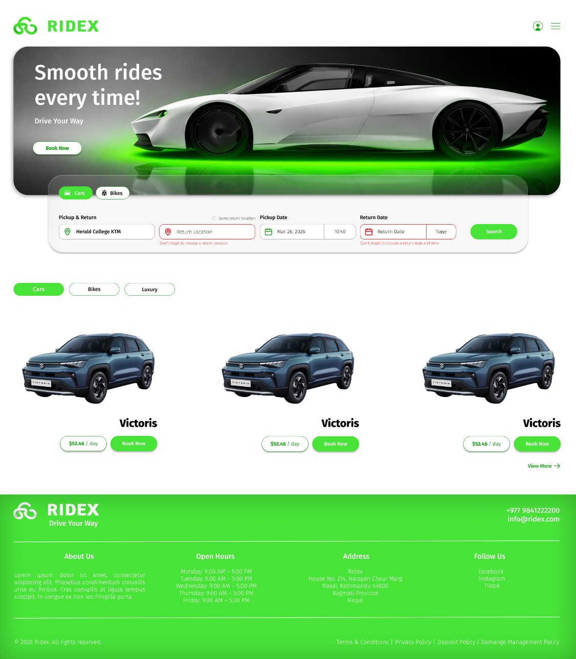
Fig 1.1: Home Page view when clicked on cars button
Description: Show different available vehicles for cars etc. sections in the wireframe all the vehicles are kept same for example only.

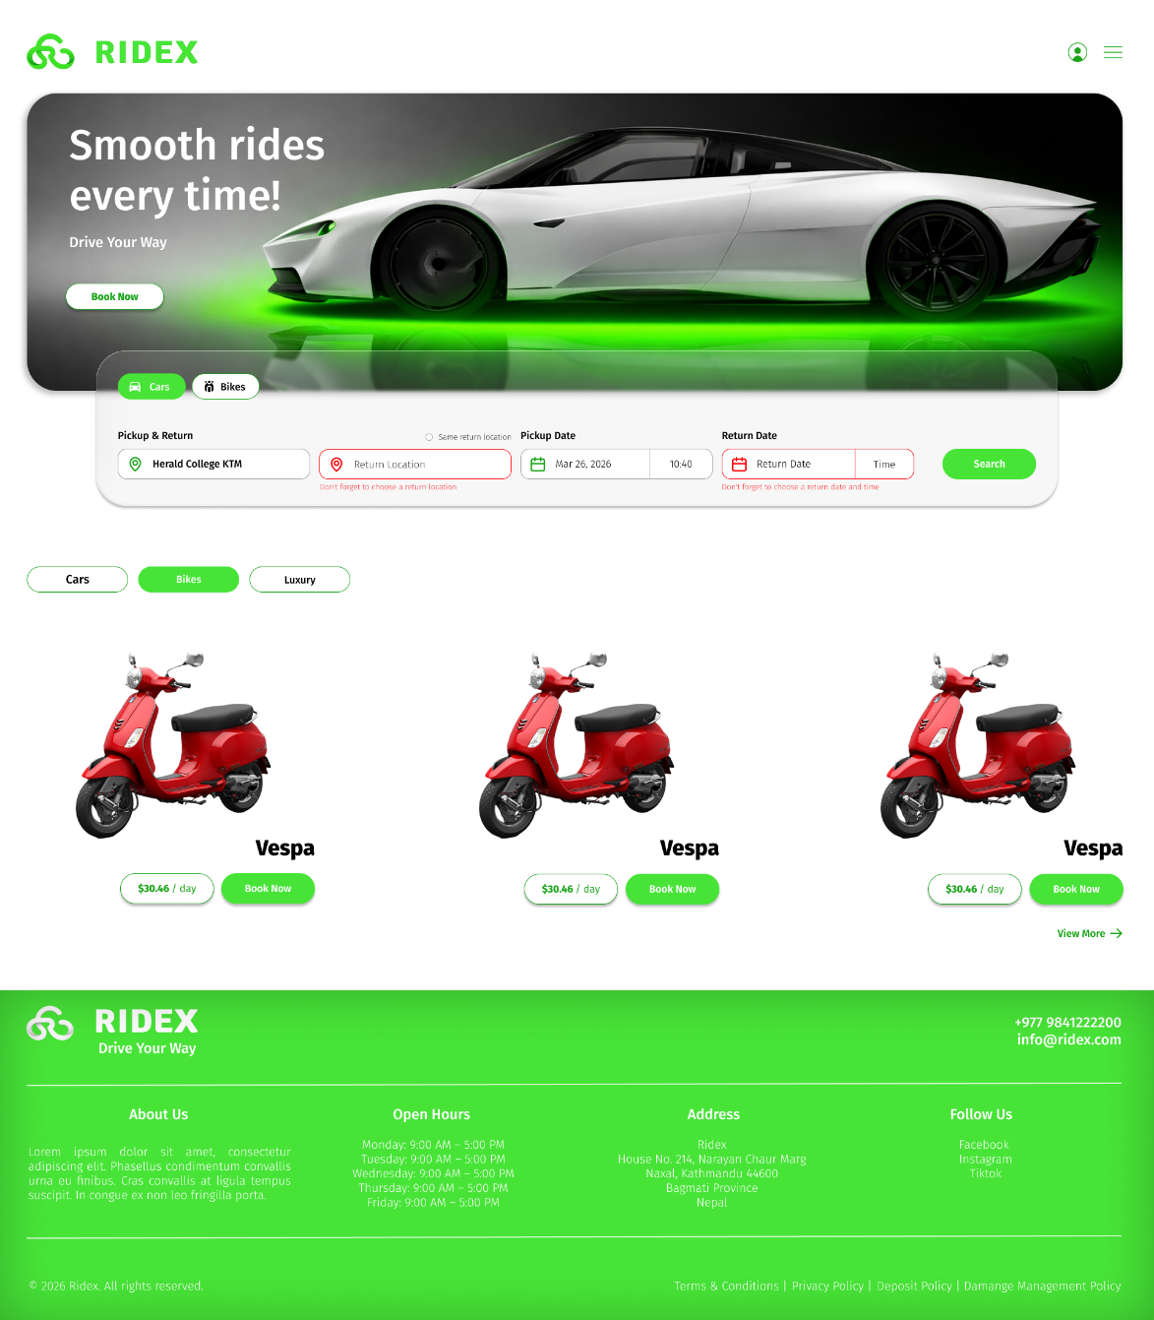
Fig 1.2: Home Page view when clicked on bikes button
Description: Switch to bikes section in homepage when clicked on the bikes button.

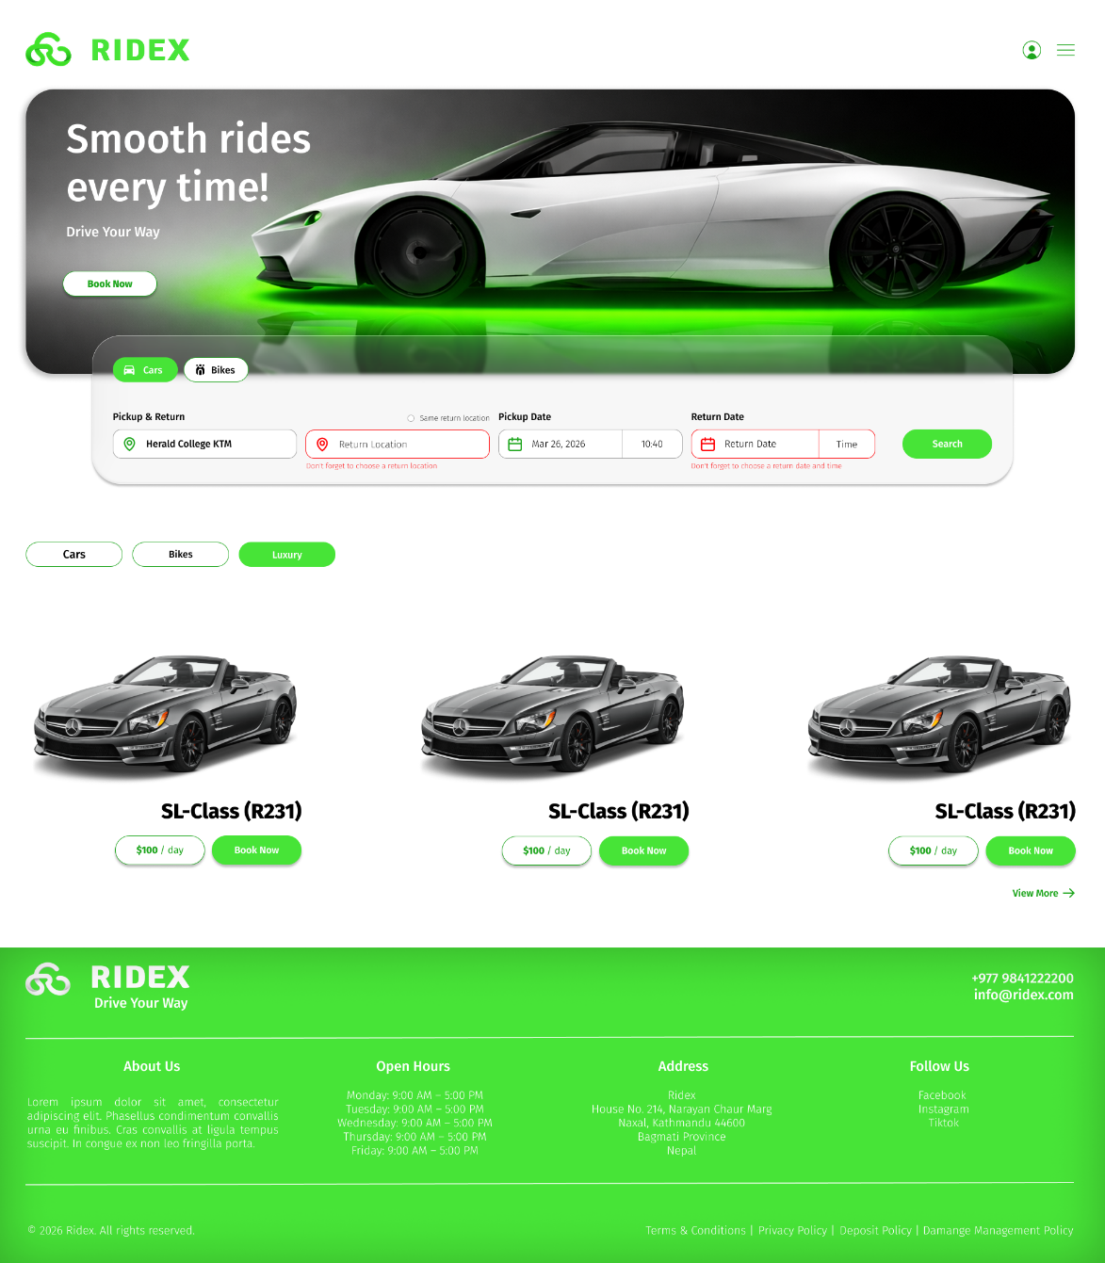
Fig 1.3: Home Page view when clicked on luxury button
Description: Switch to luxury section in homepage when clicked on the luxury button.

Home Page: Banner Section
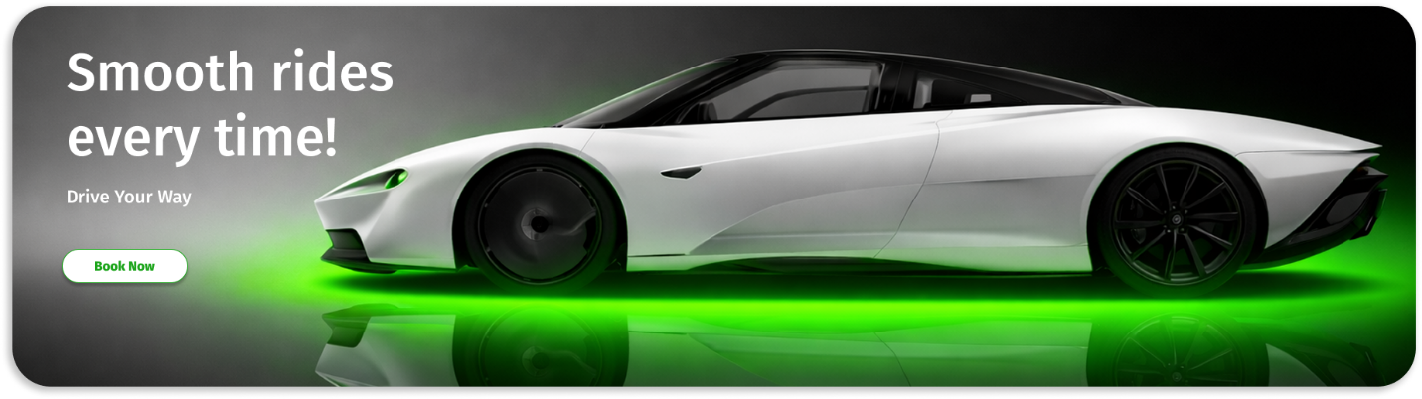
Fig 2.1: Banner section in home page
Description: Contains book now button that scrolls to the booking engine frame

Home Page: Booking Engine
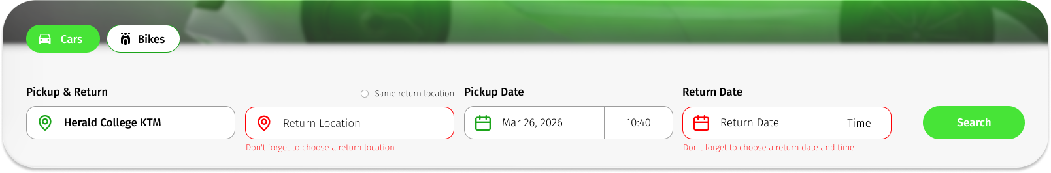
Fig 3.1: Booking engine
Description: BTW the background of the booking engine in the home page is the Apple iOS glass. So, the image on above has can be seen peeking through the transparent iOS glass background booking engine. PS need idea on how to make that effect work via code.
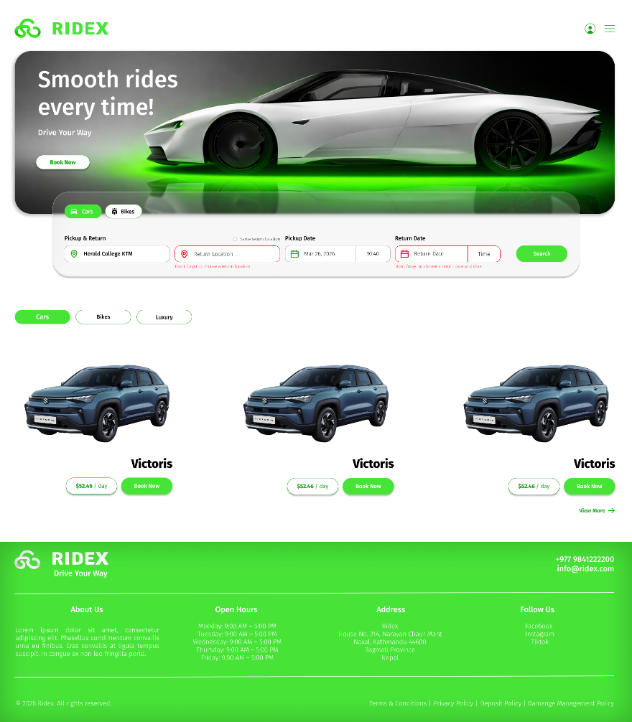
Example: How the booking engine should look against the home page.
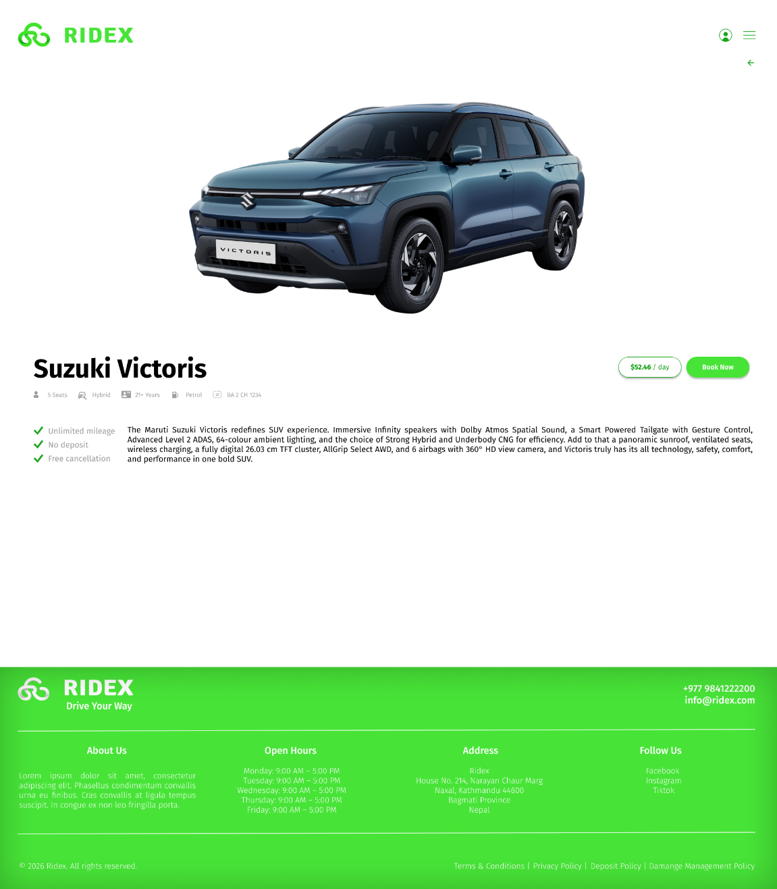
Fig 3.2: Vehicle Details page when clicked on the listed vehicle image
Description: When you click on the vehicle image on user end from home page or view more’s listing you get directed to those specific vehicles detailed listing. The Book Now button takes you to the stand-alone booking engine where you can enter location and date details and the booking process continues from there.

Booking Engine: Process Step 2
After clicking the search button in the booking engine frame. The booking process gets directed to a new page (next step):
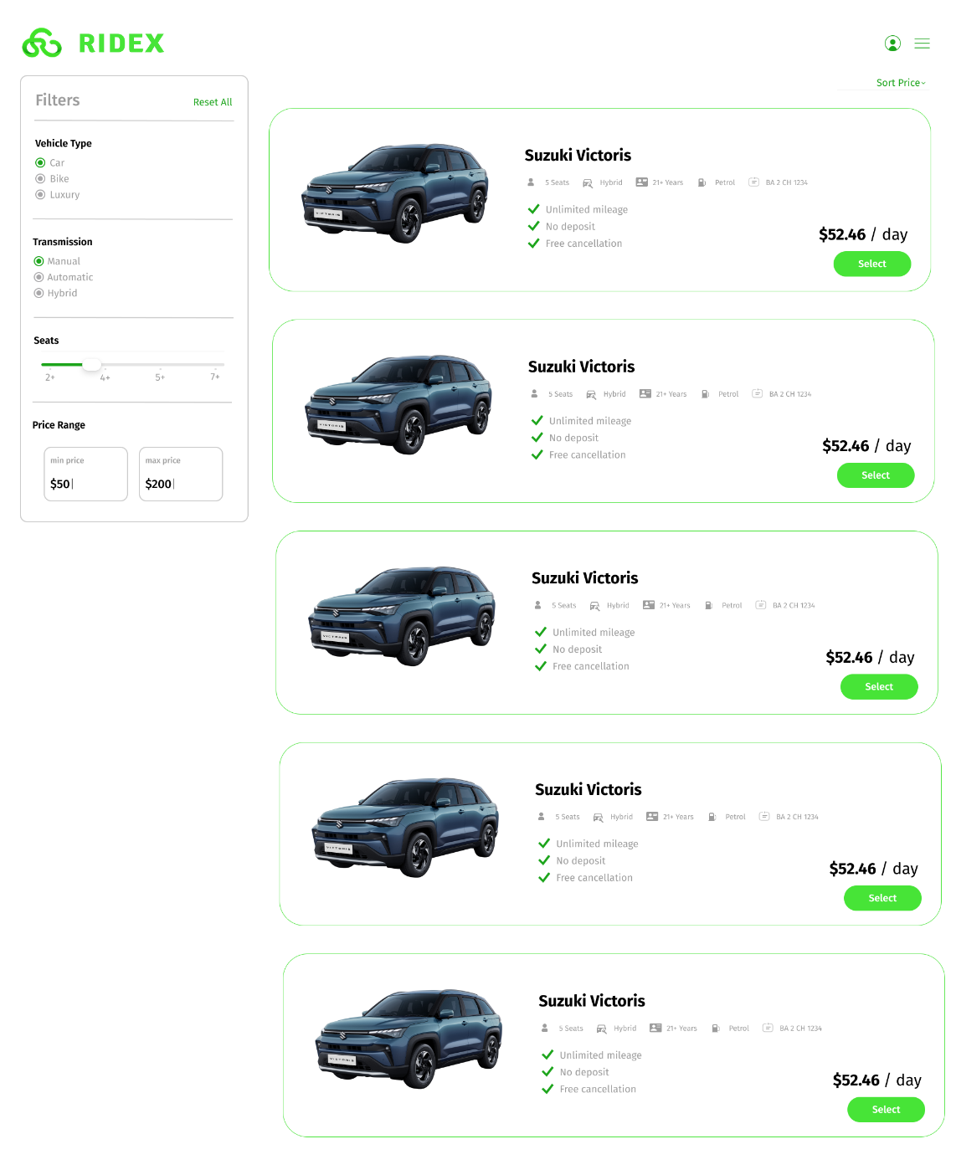
Fig 3.1.1: Vehicle selection booking part
Description: After you’ve entered all the details in the booking engine it shows the vehicle if the vehicles are available for your specific dates. If cars was selected in the booking engine home page part, then show available cars if bikes then vice versa. In this part there needs to be a filter vehicle section on the left and then the vehicles will load accordingly. It also needs a Sort feature where you can sort the price of the car from low, medium, and high. This section contains no footer.

Booking Engine: Process Step 3
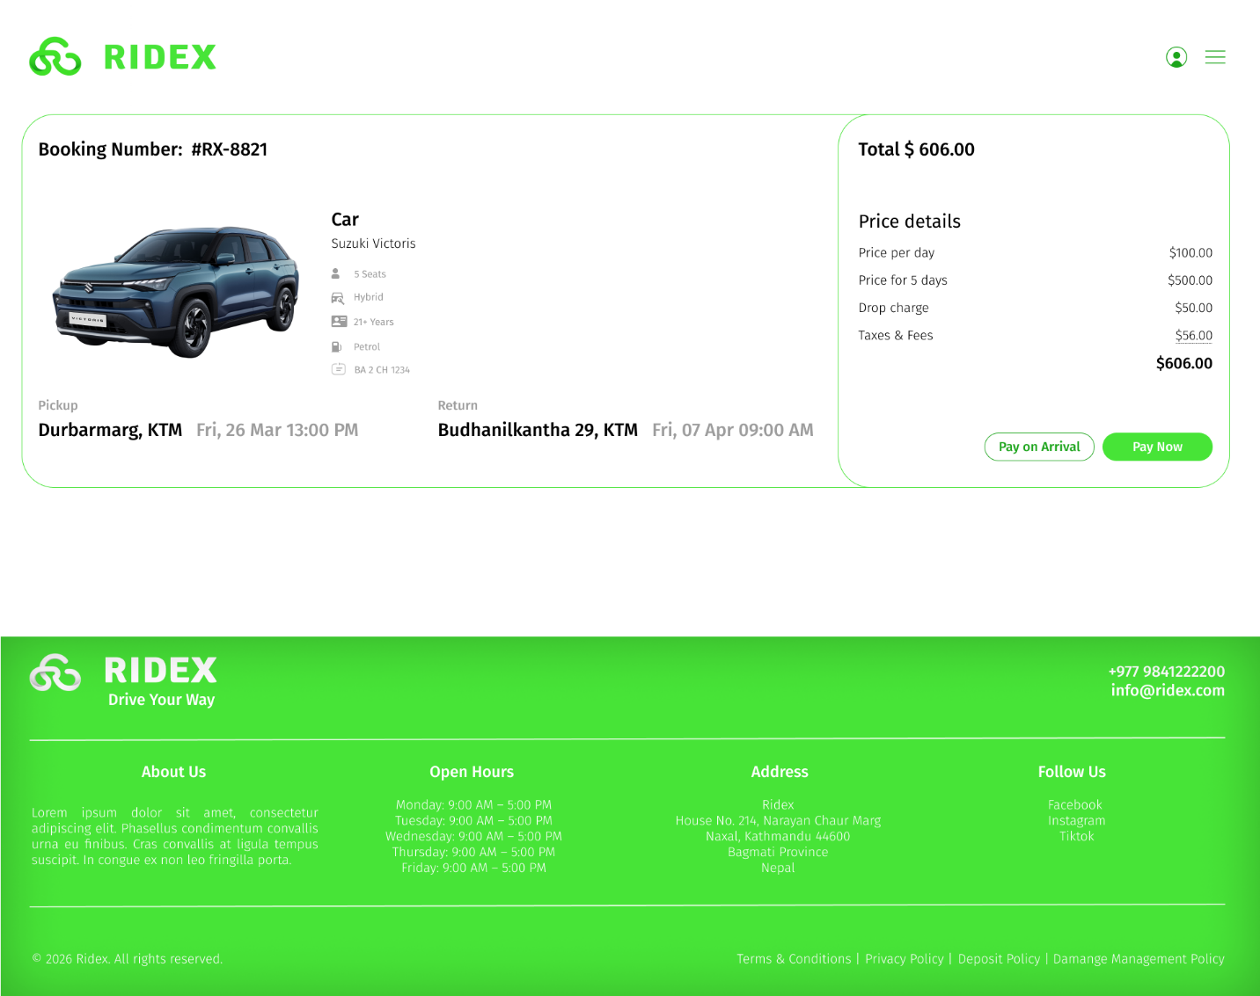
Fig 3.2.1: Booking Process Car Detail with Payment receipt on the side
Description: After you’ve selected you vehicle you get directed to this screen depending on the button you click next either “pay on arrival” or “pay now” you get directed to the specific screen.

Booking Engine: Process “Pay Now”
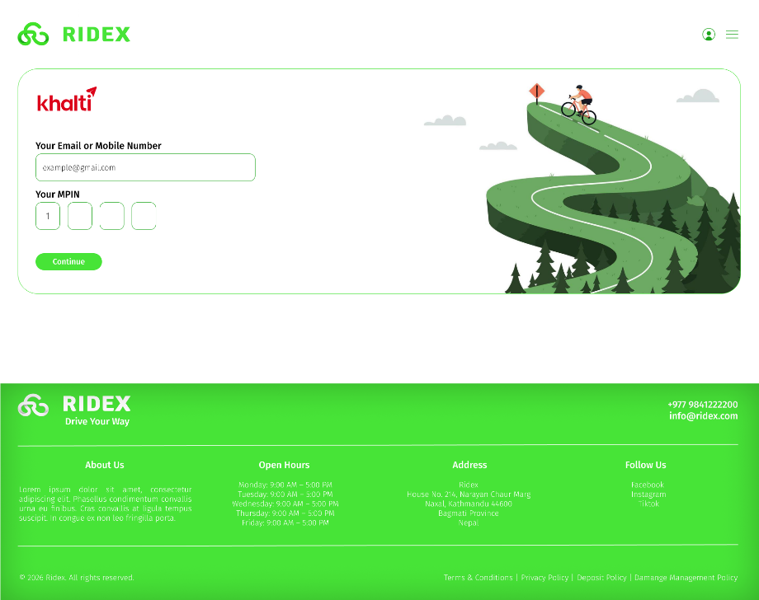
Fig 3.2.1.1: Payment Credential Screen Khalti API Integrated
Description: After you choose the Pay Now option you get taken the payment screen of Khalti integrated via Khalti API which is yet to have been figured out on how to integrate it.

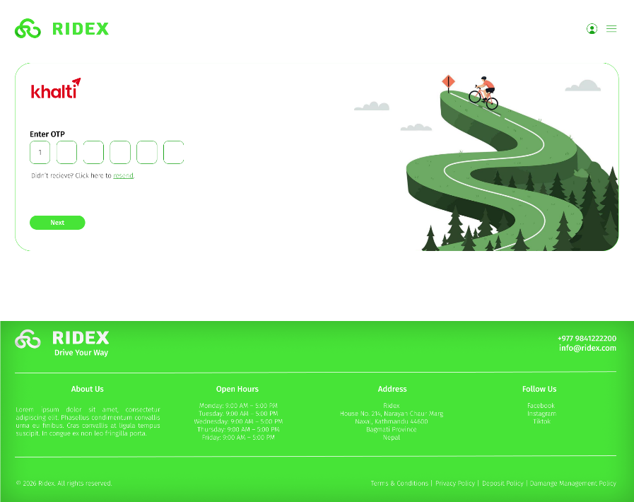
Fig 3.2.1.2: Payment OTP Screen Khalti
Description: After you enter correct Khalti credentials you get an OTP which is to be enter for the final payment to be sent to the admin.

Booking Engine: Process Step 4
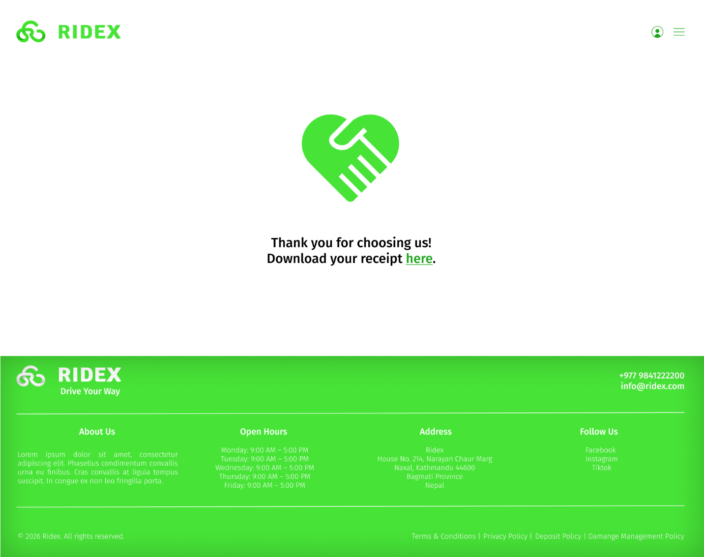Fig 3.3.1: Booking confirmed Screen with download receipt
Description: After you have chosen your form of payment if you chose “Pay on Arrival” it skips the Khalti part and directly gets taken to this page. But if you chose “Pay Now” only after you complete the payment you get directed to this page.
After this page loads, you can choose to download your receipt by clicking at the “here” link it pops up a modal. After clicking the download button in the modal, it automatically downloads the receipt in your local computer. There will be two types of receipt: paid receipt (which was paid at booking) & due receipt (which is the receipt for users who chose “pay on arrival” option)
A “booking number” get generated for each user’s booked vehicle when the booking is complete. It should follow the following format: #XX-0000 (a hashtag, then two letter, followed by a dash and four digits.

Booking Engine: Process Step 4
PS: ALL MODALS WILL BE LOCATED IN THE RIGHT HANDSIDE ALIGNED CENTER VERTICALLY FOR DESKTOP DEVICES. WITH BORDER RADIUS ENABLED ON LEFT SIDE FOR ROUNDED CORNERS.
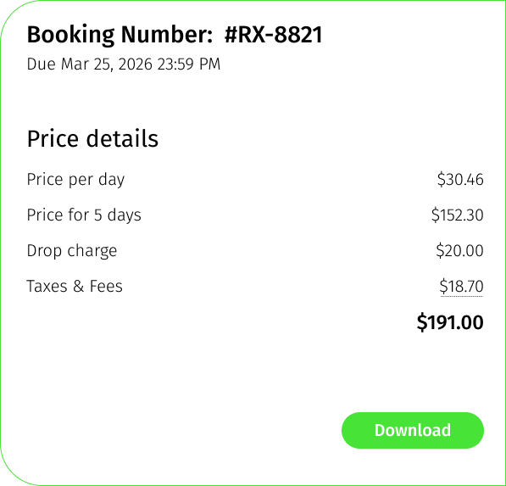
Fig 3.4.1: Receipt with download button link for Due Payment
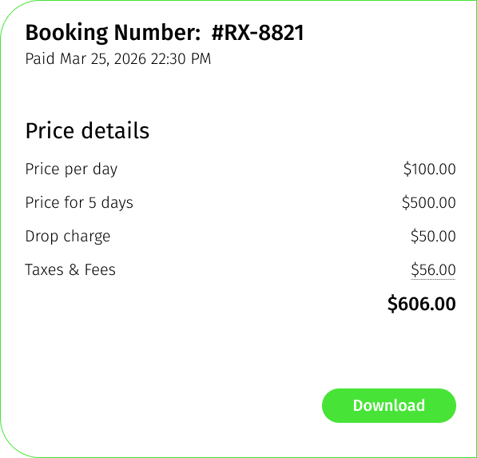
Fig 3.4.2: Receipt with download button link for Paid Payment

Booking Engine: Process Step 4.1
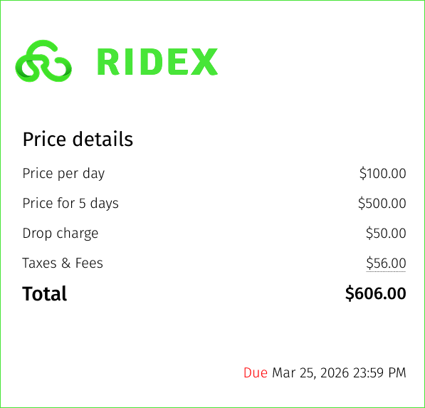
Fig 3.4.1.1: Unpaid Receipt that gets downloaded after hitting the download button
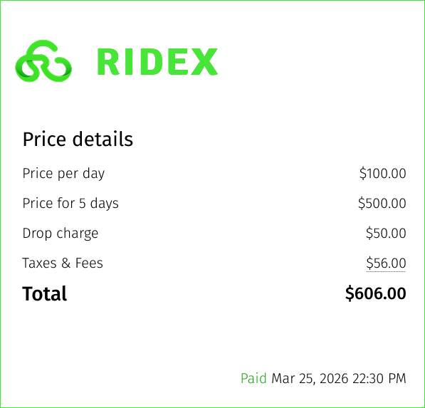
Fig 3.4.1.2: Paid Receipt that gets downloaded after hitting the download button

Home Page: Vehicle Section
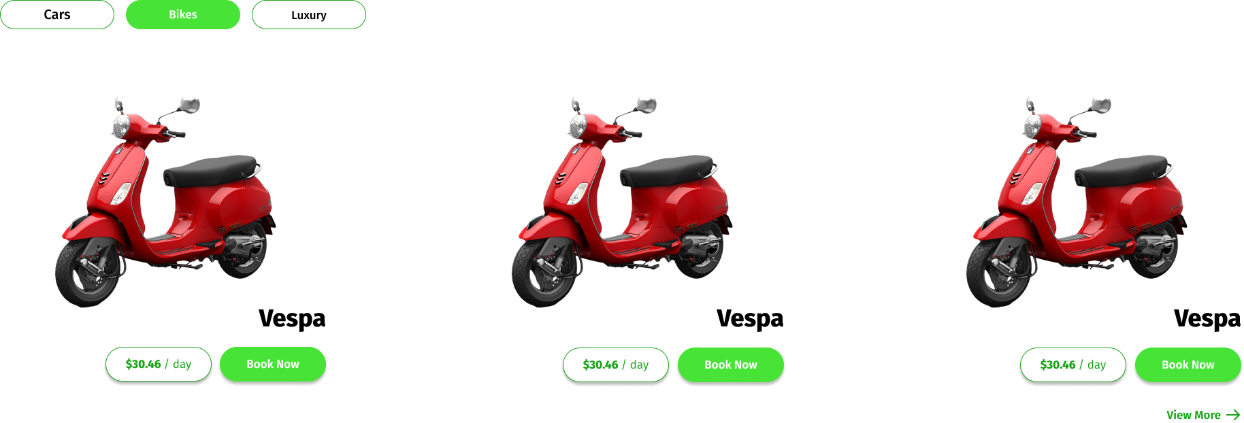
Fig 4.1: Home Page’s Vehicle Available Section
Description: Clicking on the cars, bikes or luxury button switches the vehicle category shown. Clicking the “Book Now” option takes you to a confirming modal.
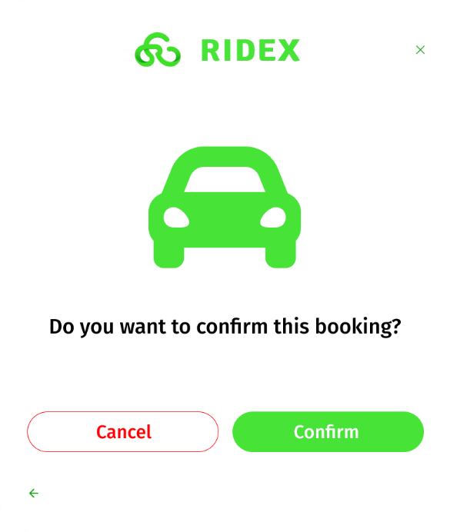
Fig 4.2: Confirm Booking Modal
Description: After clicking the “Book Now” option in the home page’s vehicle category section user gets this modal to confirm the booking to move on to the next page. After clicking the confirm button in the modal they get taken to a separate stand-alone booking engine page.
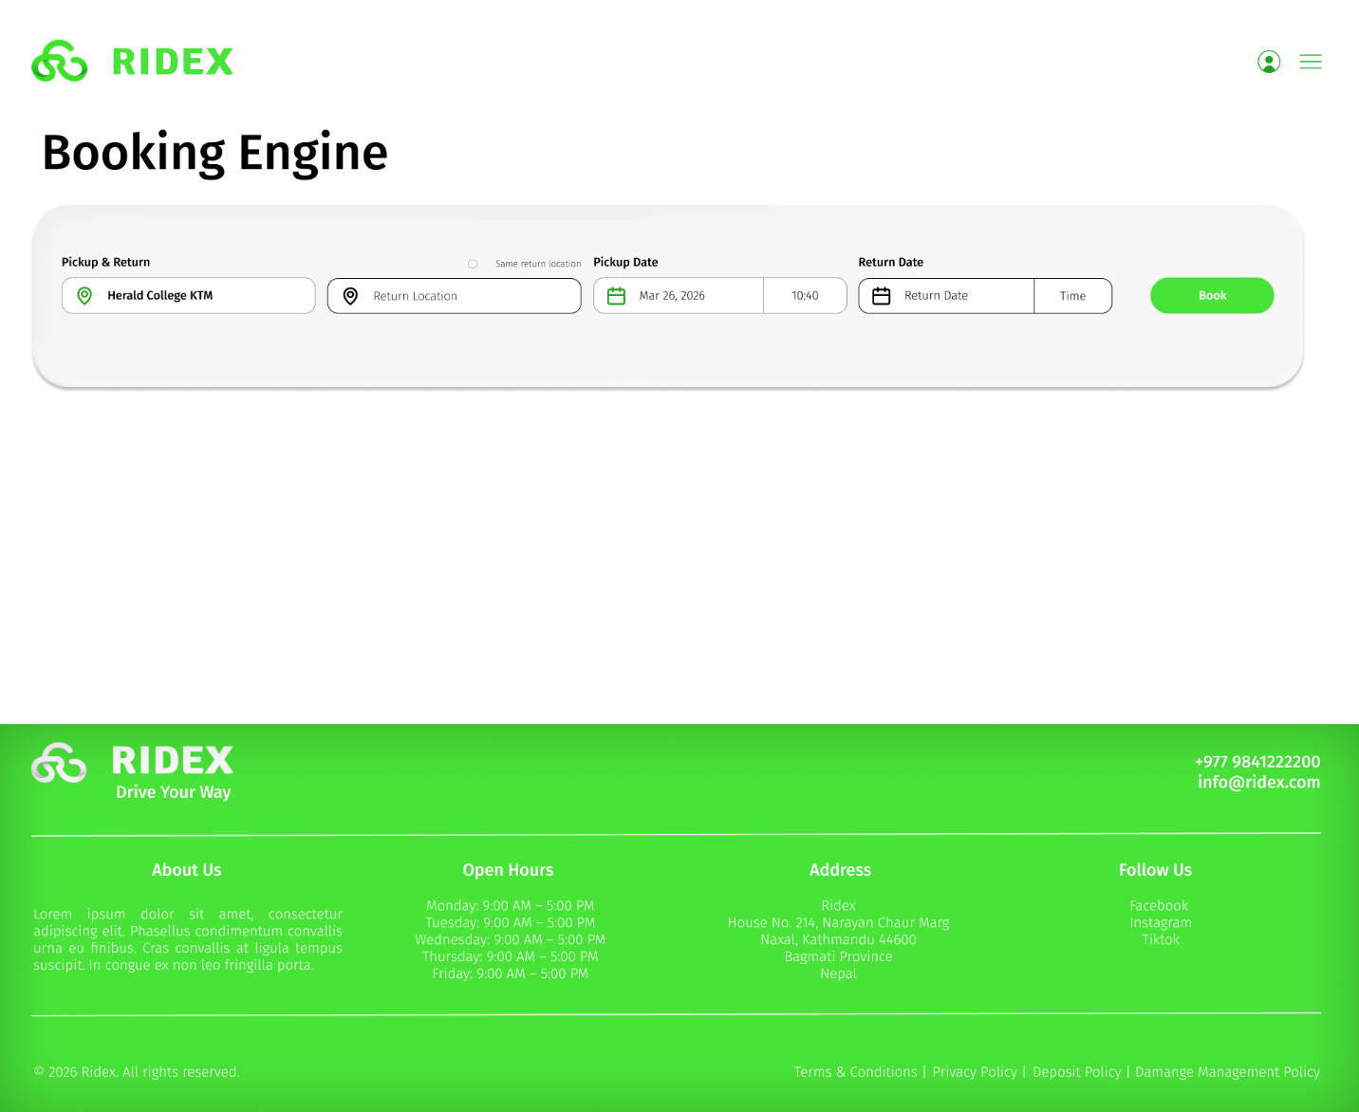
Fig 4.3: Booking Engine for booking from home page’s vehicle display category
Description: After putting in all the details you can click the “Book” button from where it directs you to the old “Fig 3.2.1 : Booking Process Car Detail with Payment receipt on the side” screen.

Home Page: Vehicle Category View More Expansion

Description: The “view more” button on the home screen’s vehicle category takes you to a full page of listed vehicles of the chosen category.
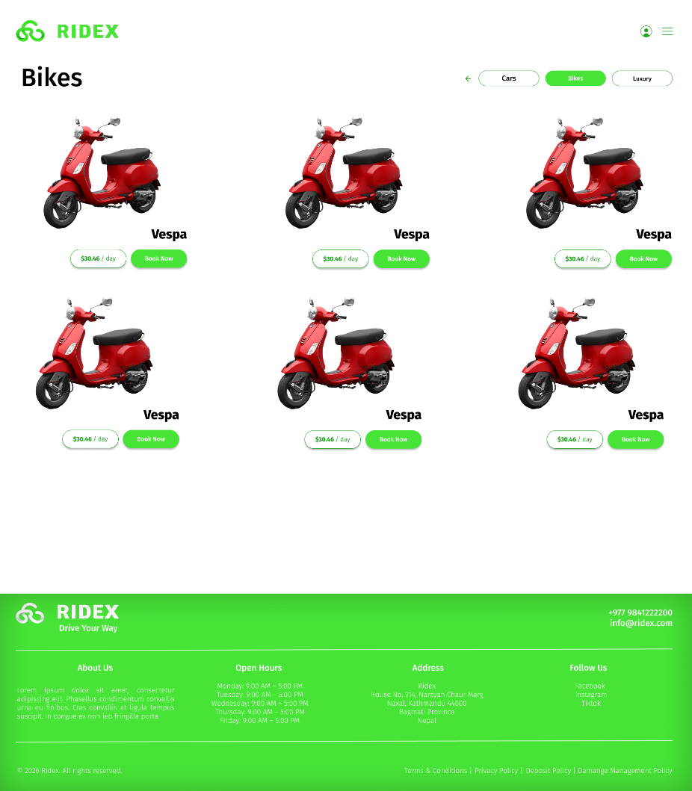
Fig 5.1: All listed vehicle category
Description: After clicking the view more button from the specified category it takes you to the full page of available vehicles and in that page too you can switch the vehicle category and there is a back button to return to the home page. And the “Book Now” button here as well takes you to the stand-alone booking engine page and the booking process continues from there like for booking from other parts of the website. Clicking the vehicle’s image here as well takes you to the detailed single vehicle dedicated page as seen before.

Home Page: Footer Policies
Description: The footer.php page includes policies on the bottom right-hand side clicking on each policy redirects you to the dedicated policy page for each policy. Also the Follow Us sections social media listing when clicked open the dedicated link in a new tab.
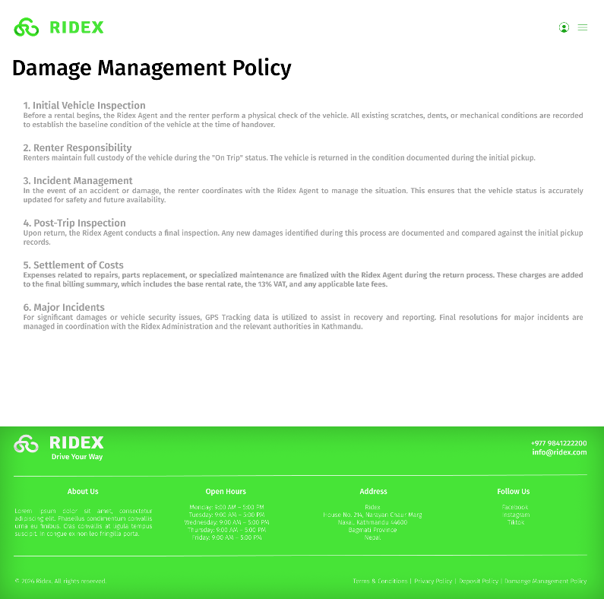
Fig 6.1: Damage Management Policy
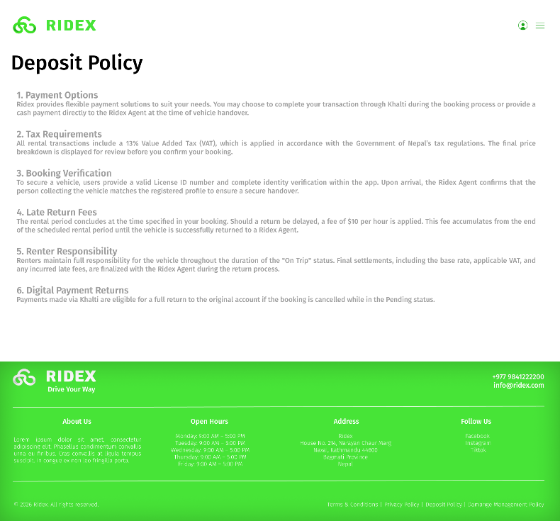
Fig 6.2: Deposit Policy

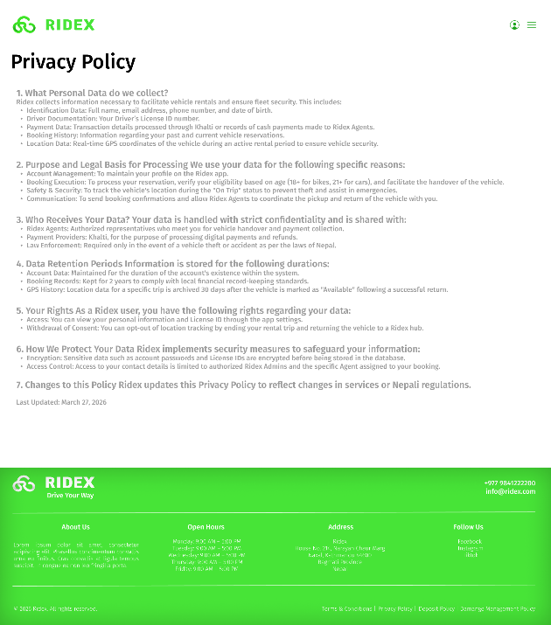
Fig 6.3: Privacy Policy
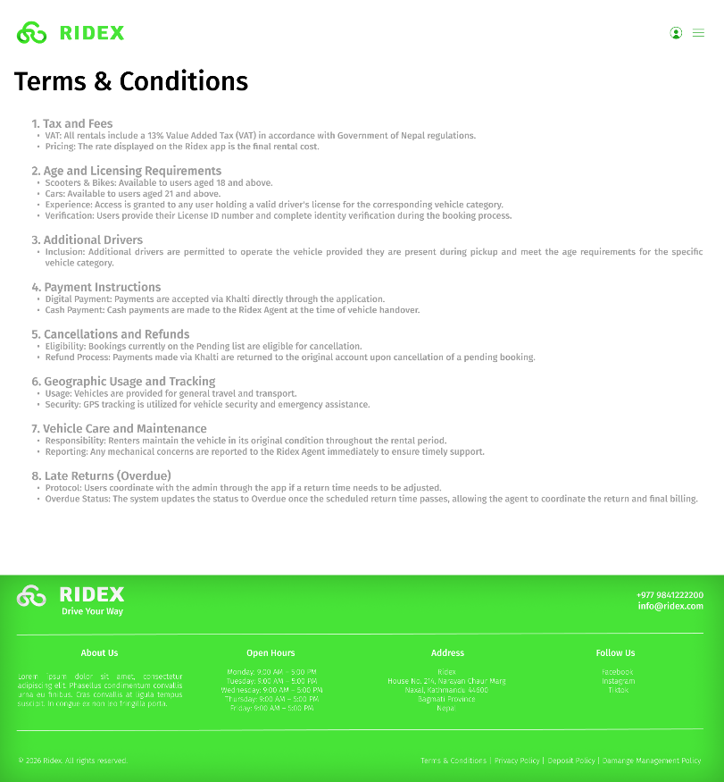
Fig 6.4: Terms & Condition

Home Page: Menu Button’s Modal
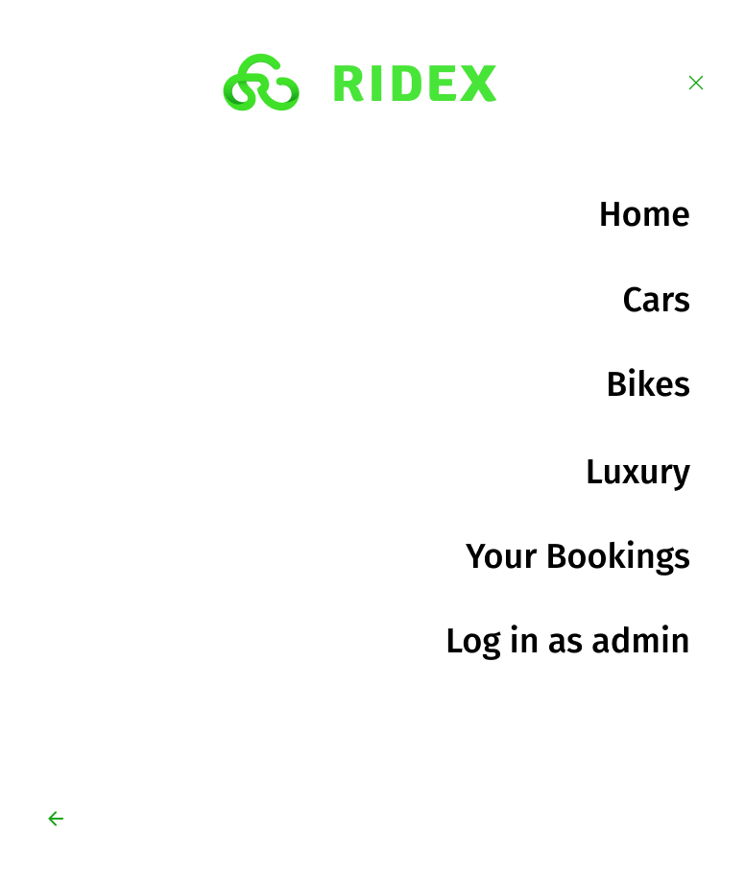
Fig 7.1: Menu Popup Modal
Description: On the navigation bar when the menu button is clicked the menu modal pops up from where you can click different items
- Home: Takes you to the main home page/landing page
- Cars: Takes you to the listing of all available cars for users (home page’s vehicle category’s “view more” button takes you to the listing of all available cars too likewise this is the same)
- Bikes: Takes you to the listing of all available bikes for users
- Luxury: Takes you to the listing of all available luxury vehicles for users
- Your Bookings: If logged in it takes you to the “Your Bookings” Page. If not logged in the log in for user modal pops up.
- Log in as admin: Takes you to the login page for admins

User Log In
When clicked on the user icon in the navigation if the current user is not logged in it takes them to the login modal whose steps are as followed:
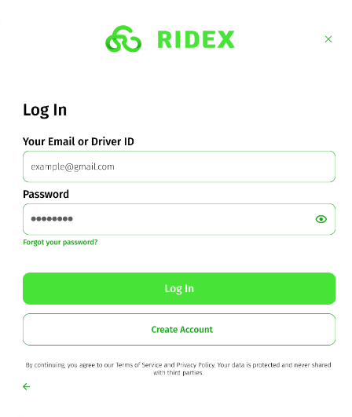
Fig 8.1: Login Page
Description: If the current user is not logged in when click on the user icon this login modal pop ups for them to log in if they have previously created an account. Otherwise, they can select to create account.
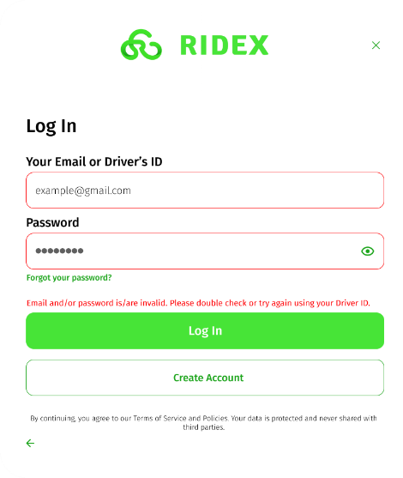
Fig 8.2: Incorrect Credentials
Description: Either password or license/email entered incorrect then the text in red pops up saying that the credentials are incorrect and the text fields border turns red.
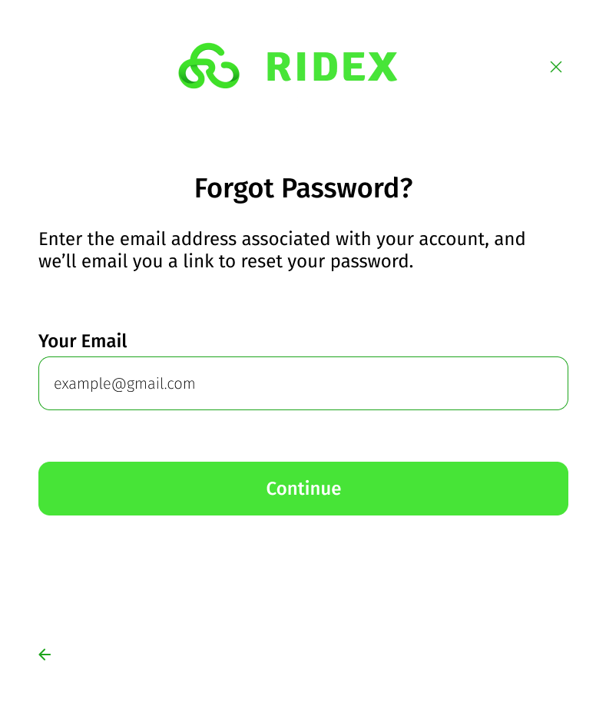
Fig 8.3: Forgot Password Modal
Description: From the login modal if you forget your password this modal pop ups where you need to enter your email.
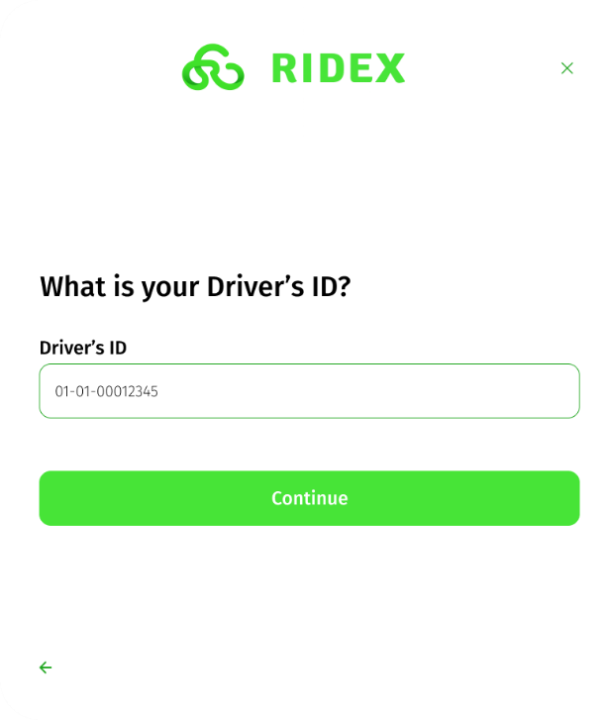
Fig 8.4: Forgot Password Drivers ID
Description: After you have entered the email then you need to enter your drivers id.
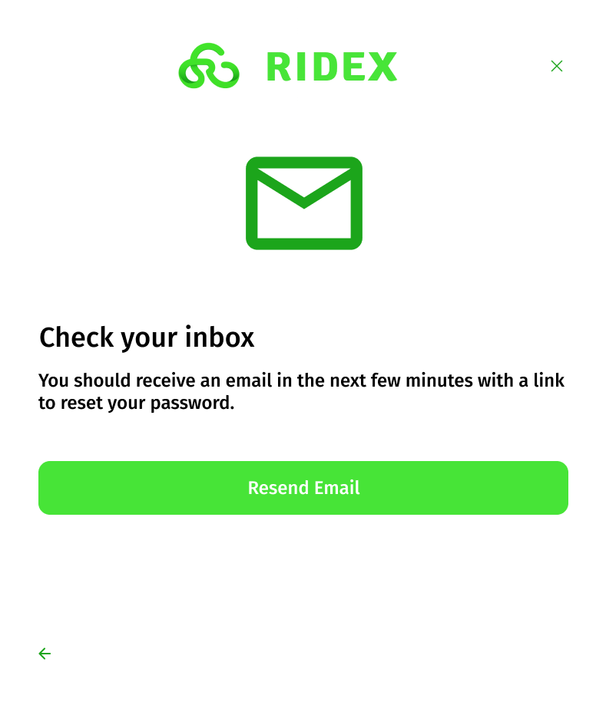
Fig 8.5: After entering and continuing from the drivers id section and email gets sent to you address. If you didn’t receive any mail you can choose the resend email button which send the 2nd mail and it also redirects to the first login modal.

User Create Account
Through the same user login modal clicked from the navigation header if you aren’t logged in. If you don’t have an account you can choose to create an account and the following steps occur:
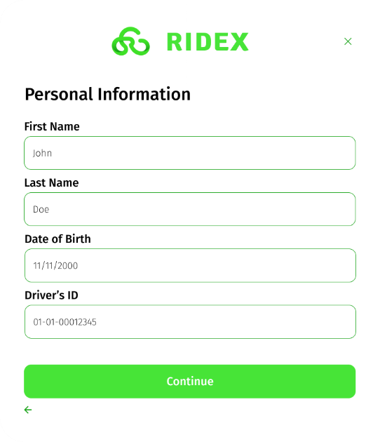
Fig 9.1: Create Account Modal
Description: After you’ve clicked create account in the log in modal you get directed to the create account modal its first page is to enter personal details for account creation.
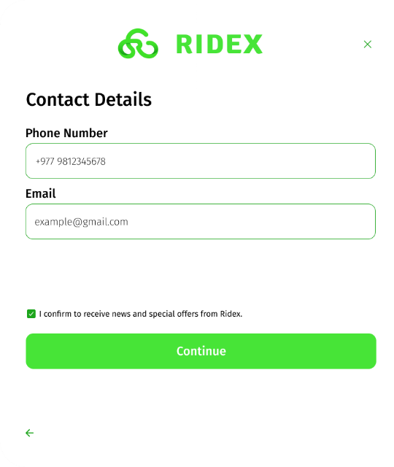
Fig 9.2: Create Account Contact Details
Description: Enter your contact details for account creation and login purposes. This is the 2nd step.
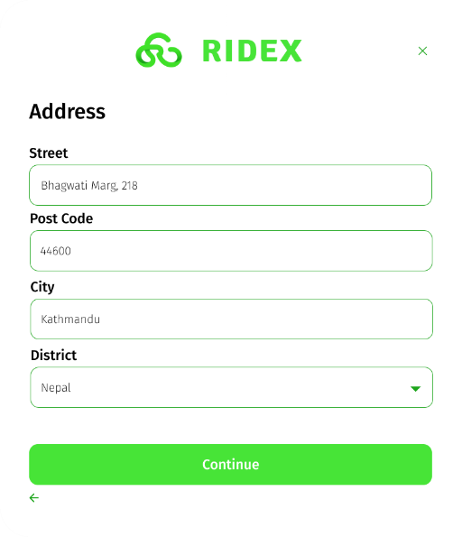
Fig 9.3: Create Account Address Details
Description: Fill in address details. This is the 3rd step.
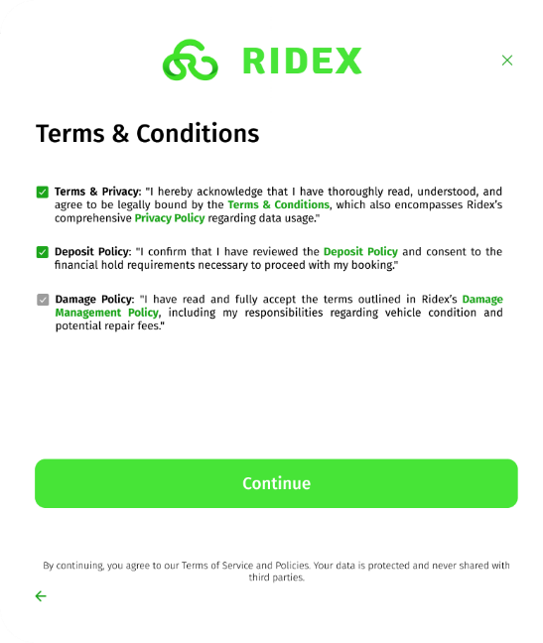
Fig 9.4: Create Account Policy Agreement
Description: Tick on the policies to create your account with out ticking the and agreeing you are not eligible to create the account and the continue button doesn’t click.
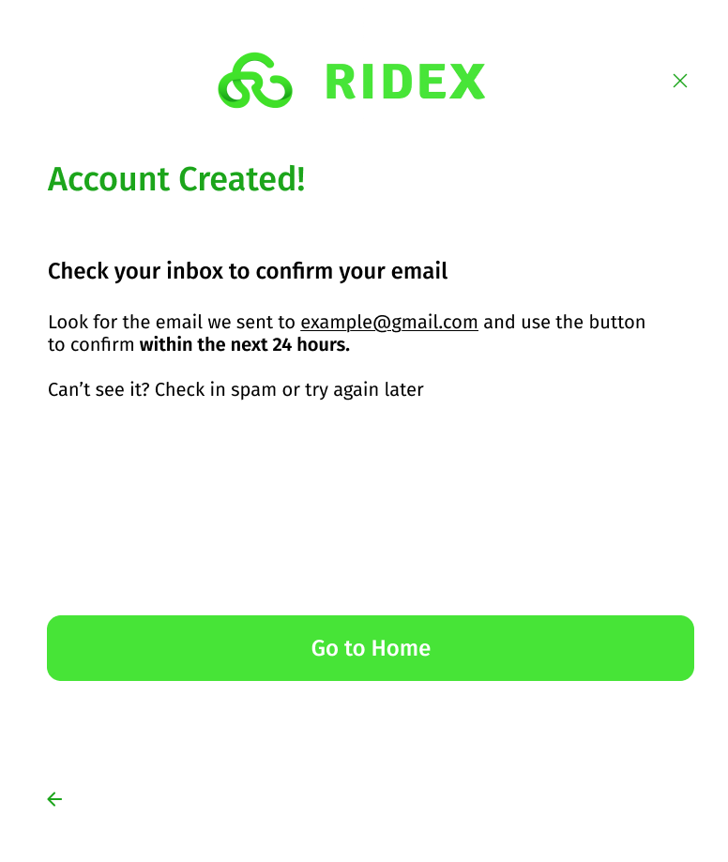
Fig 9.5: Create Account, Account Created
Description: After agreeing to all the policies your account will be create and this modal will pop up confirming account create then you can click the go to home button which redirects you to the home page/landing page.

Already Logged in User
For previously logged in user’s when clicking the user icon in the navigation header the pop up will be different and like so instead of a generic login page:
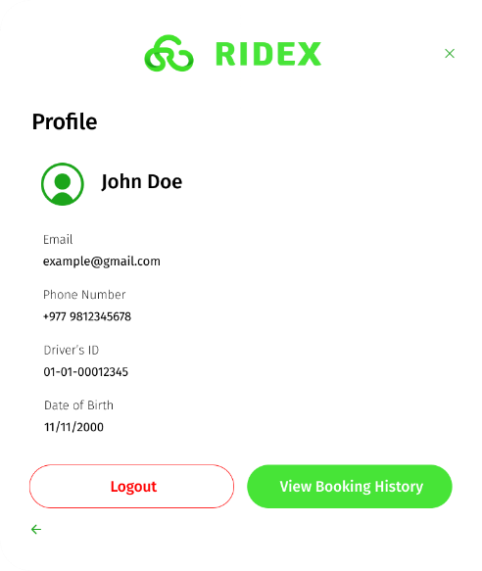
Fig 10.1: Already Logged in user’s “navigation header’s user icon” pop up modal
Description: Instead of the classic log in modal if a user has already logged in the instead of the login modal this modal shows up instead clicking on the same navigation header’s user icon.
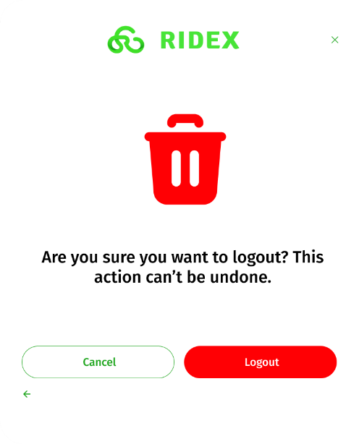
Fig 10.2: Confirm logout modal
Description: If the user wants to logout and click the logout button then an extra confirmation screen popups to ensure accidental logouts. Only after clicking logout here, they’ll be logged out and redirected to fresh unlogged home page/landing page.

Already Logged in User: View Booking History
You can see your booking history from two ways:
- Navigation header’s user icon: which pops up the profile information modal with the users’ details and two button one to view the booking history and other is to logout.
- Menu “Your Bookings” section: In the nav header menu icon there is a “Your Booking’s” section if logged in it redirect to the the users booking page if not logged in then to the login modal.
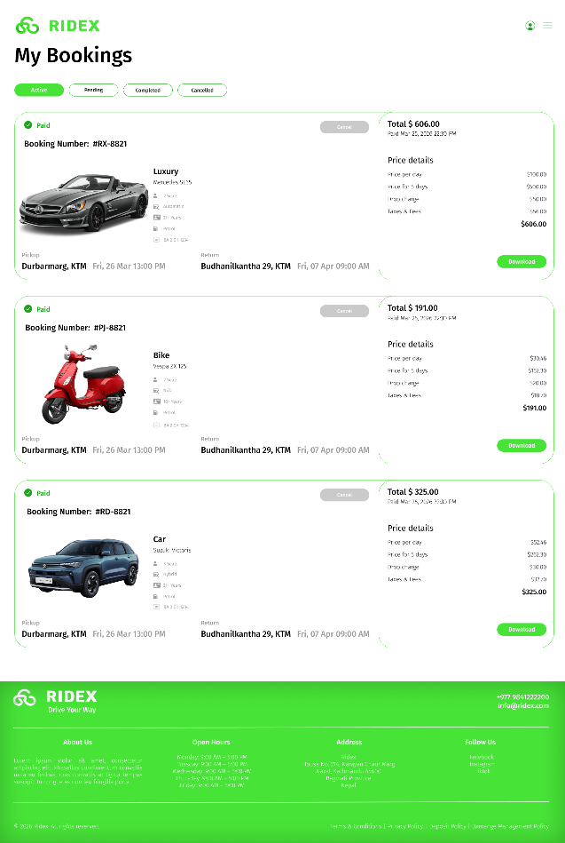
Fig 11.1: My Booking Page
Description: There are 4 sections in the “my bookings” page where user can track their booking, cancel it, or view completed booking and active bookings. Active bookings cannot be canceled since the vehicle is with the user and is on trip. And when tabs are switched it should go the cancelled, completed, pending and show the respective booking history of that section. Download button download the same receipt from the booking payment process seen earlier but the paid/due system is still valid over here in the receipt.
PSA: The active booking page shall only contain one booking but in fig 11.1 there are three booking only to show the variations of how different each vehicle category booking looks like.
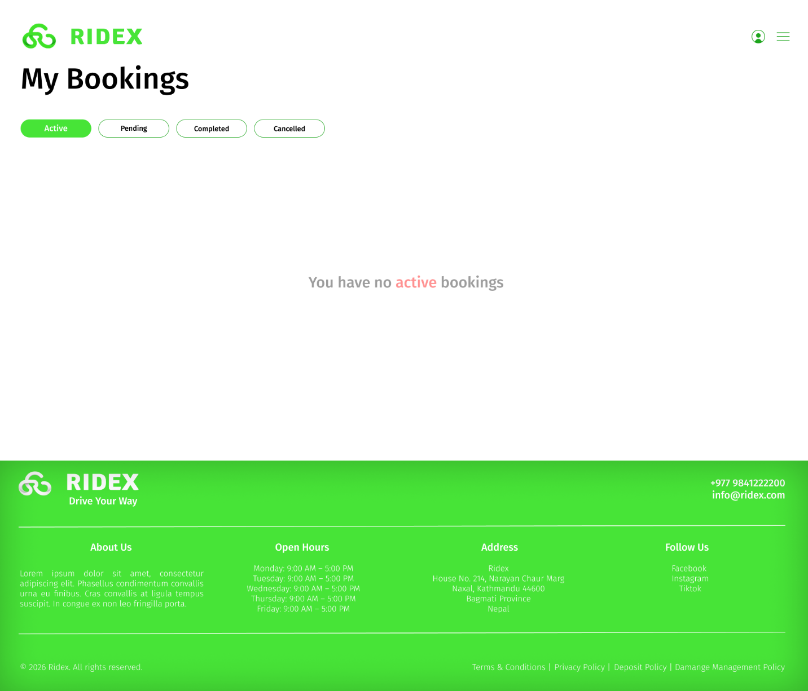
Fig 11.2: No bookings
Description: If a user has 0 active booking currently then instead of showing the booking detail the website should show an alternative text that says “You have no active bookings”
Also, for pending, completed, and cancelled bookings section if there are no such booking then it should also show the text saying:
- You have no pending bookings
- You have no completed bookings
- You have no cancelled bookings
ETC for each section.

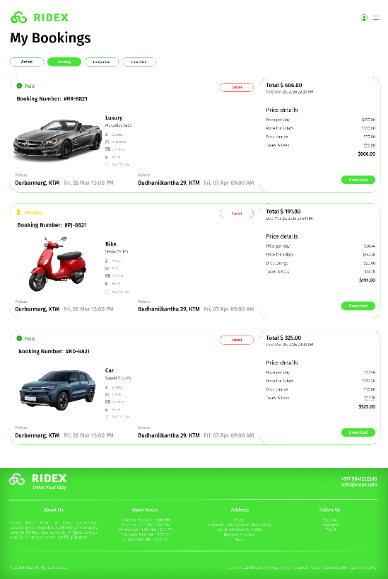
Fig 11.3: My Bookings Pending Sections
Description: The pending my booking section shall show reserved for future vehicles. It can be cancelled since the vehicle is not on trip.
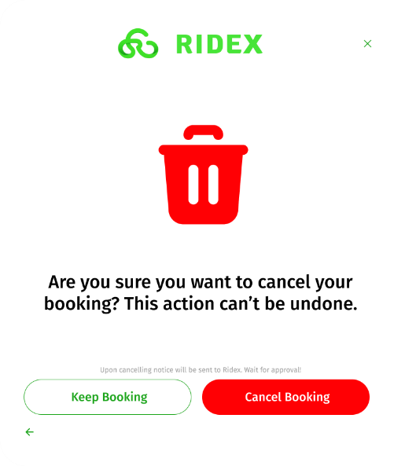
Fig 11.4: Cancel Booking Modal
Description: If any vehicle booking on the pending section gets cancelled then this modal pops up to confirm the cancelation and the admin gets to approve the cancellation only after things happen from admins side can one receive their payment if they pre-paid while booking.

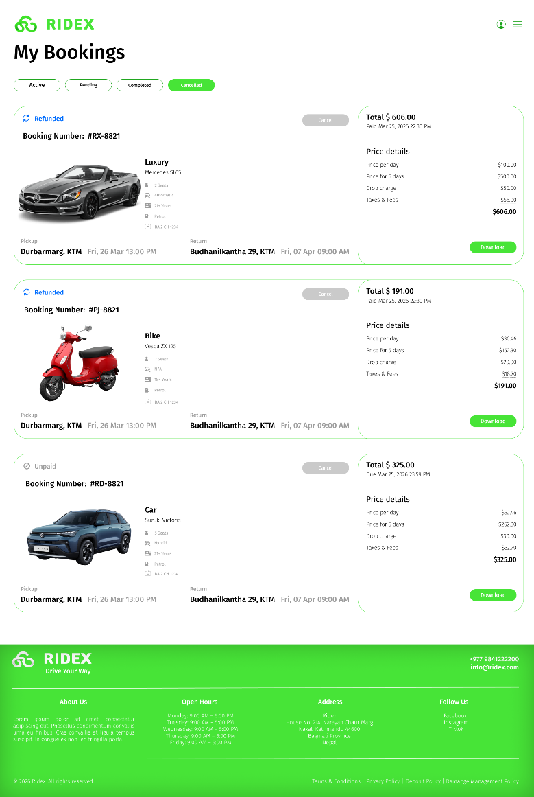
Fig 11.5: My Bookings Cancelled Section
Description: This section lists all the cancelled vehicles from past and thus the cancel button is grey here which means it cannot be clicked.
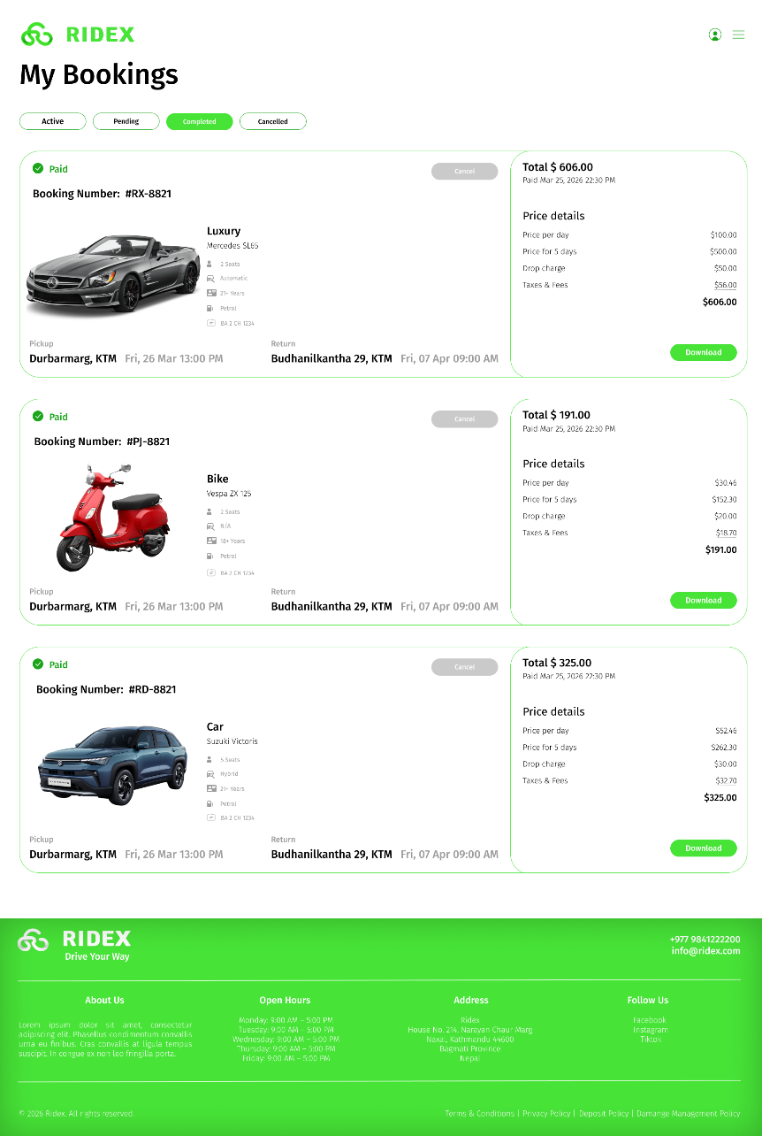
Fig 11.6: My Bookings Completed Section
Description: This section shows the list of all past completed bookings.

User Payment Status

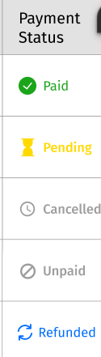
- Paid: Full payment received at booking.
- Pending: Booking made, but "Pay on Arrival.
- Refunded: Money sent back after a cancellation. (After approving cancel request)
- Cancelled: The transaction is voided (booking cancelled), but the refund has not been processed yet. (after this gets approved it moved to refunded status)
- Unpaid: Pending payment that has been cancelled

Admin Login
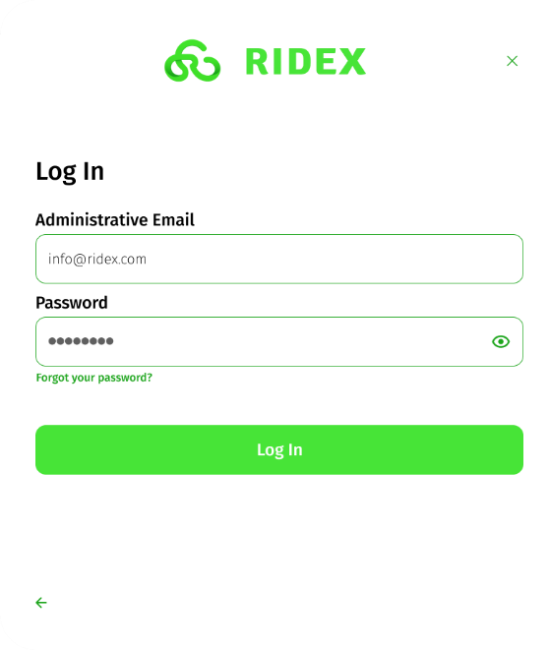
Fig 12.1: Admin Login
Description: From the navigation header menu button there is an option to log in as admin when clicked the admin login modal pop ups for admin to manage and track vehicles and user.
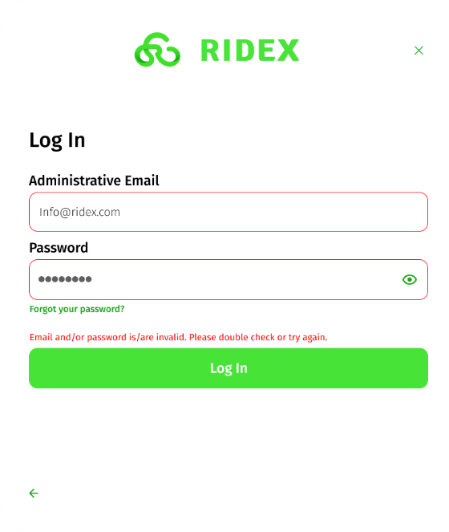
Fig 12.2: Admin Login Incorrect Credentials
Description: Incorrect Credential warning text field border red
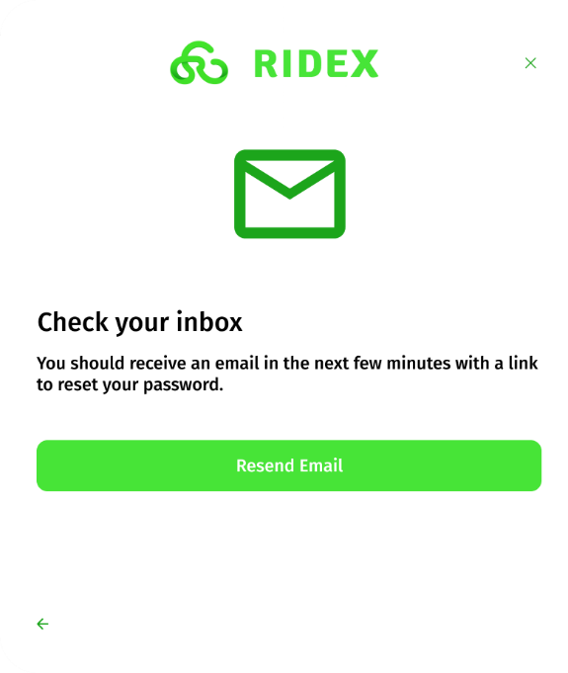
Fig 12.3: Admin Login Forgot Password
Description: If the admin clicks forgot password then get this modal popup to reset the password. If they don’t receive an email they can choose to click the resend email button to get the reset email again. After clicking the resend email button it directs you to the main home page/landing page.
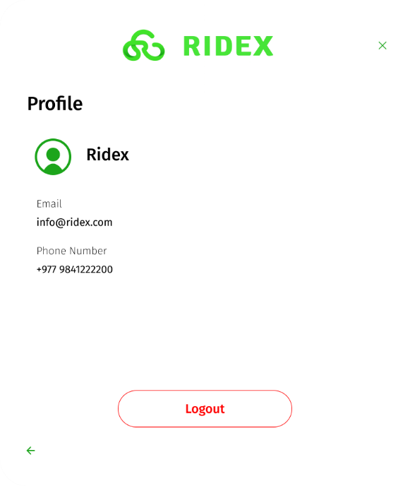
Fig 12.4: Admin Profile
Description: After an admin has logged in when clicked on the navigation header’s user icon the admin details shall show upon clicking. When the logout button is clicked it directs to a logout confirmation pop up.
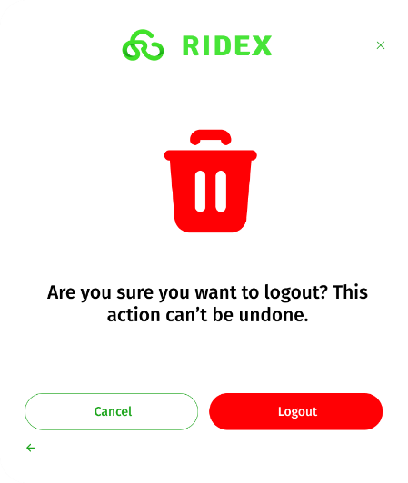
Fig 12.5: Admin Logout Confirmation Modal
Description: When an admin clicks the logout button in the admin profile modal the logout button opens this modal to avoid accidental logouts only after clicking the logout button here can they logout and be directed to the home page/ landing page.

Car Status
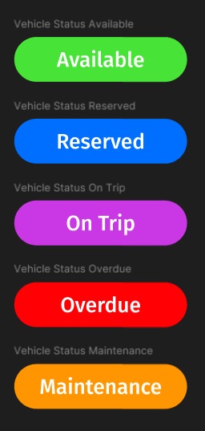
- Available: If vehicle has no bookings
- Reserved: If the vehicle was booked
- On Trip: If the vehicle is active and on ride
- Overdue: If the booking date is over but user still hasn’t returned the vehicle (This results in a late fee; 1 hour = $10)
- Maintenance: If the vehicle has gone for maintenance at workshop

Admin Home
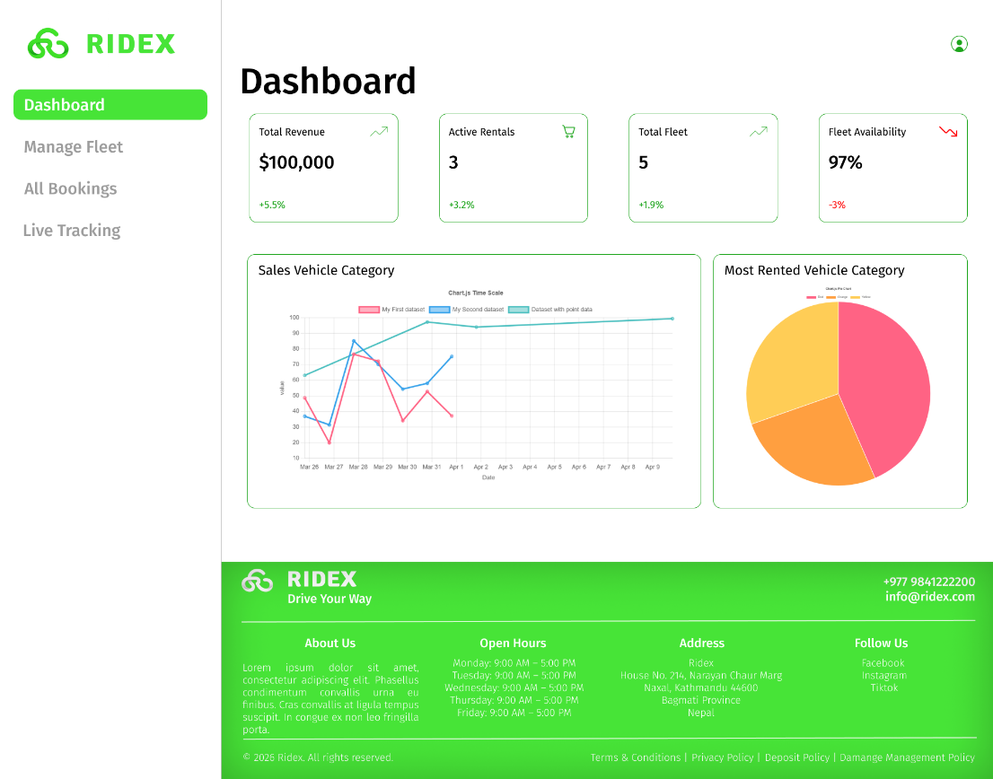
Fig 13.1: Admin Home Page Dashboard Section
Description: This is the home page for admins the first section is the dashboard where admins can view the status of their revenue, vehicles, etc. calculated through codes etc. Also, Admin has no menu button on navigation header only users can access it since its of no use to the admin. The footer part does not take the full width in the admin pages unlike in the user pages. In admin UI the sidebar is taking some of the width so the footer for admin section are not full width.
- Total Revenue: Calculated total earning with + or – value in percentage.
- Active Rentals: The number of on trip vehicles with + or – value in percentage.
- Total Fleet: The total number of vehicles the company has with + or – value in percentage.
- Fleet Availability: How readily are vehicles available for booking with + or – value in percentage.
- Line Graph: Showing three lines in one graph for each vehicle category car, bikes, and luxury and its respective sales.
- Pie Chart: Showing three sections for each vehicle category showing which vehicle category is rented out the most either bikes, car, or luxury.

Admin Manage Fleet
This is the section where admins can manage their vehicles like create new vehicles changing status to maintenance, editing vehicles, and deleting vehicles. Basically, CRUD for vehicles.
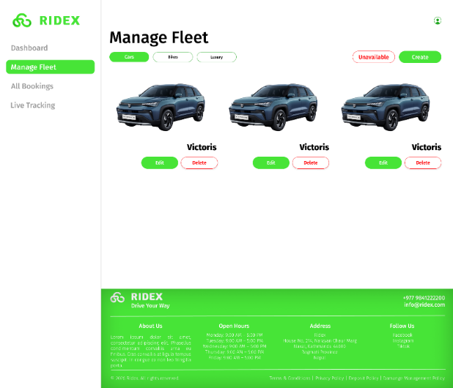
Fig 14.1: Manage Fleet Available Vehicles
Description: Section of all listed vehicles categorized into cares, bikes, and luxury, can edit, view, delete and create vehicles. When clicked on the picture of the vehicle the pop-up modal with vehicle details shows. Can switch to bikes, cars, and luxury vice versa. It also highlights Unavailable category button that has its own listings.
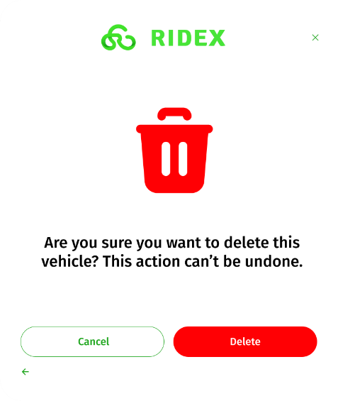
Fig 14.2: Delete Vehicle Pop Up Modal

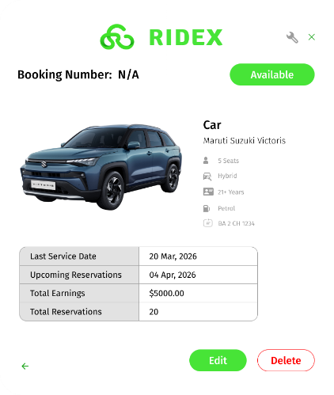
Fig 14.3 Read Available Vehicle
Description: This modal pops up when clicked on the vehicle image depending on where the vehicle is listed the details such as booking number, available, and table details change.
For Available cars the booking number is n/a. And it shows the car status in the right handside “Available”. The table for available vehicle specifies: last service date, upcoming reservations if any, total earning made for this specific vehicle, total reservations. All of this must be calculated through coding. There is also a maintenance button beside the close icon for available vehicles which add its to maintenance vehicle status with a pop-up modal that with description to add it to maintenance.
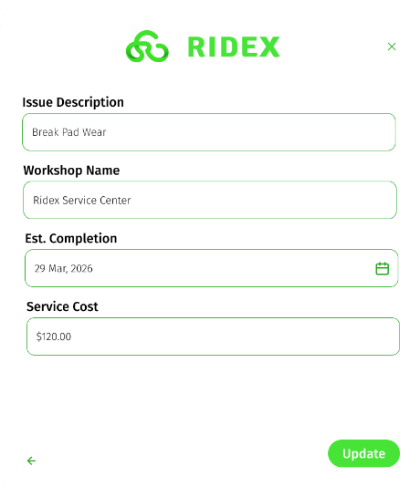
Fig 14.4: Maintenance Fillup
Description: After clicking the maintenance button in the Read Available Vehicle modal this maintenance fillup form opens after filling it you can click the update button which then shows the pop up of the same car but the car status changed to maintenance.
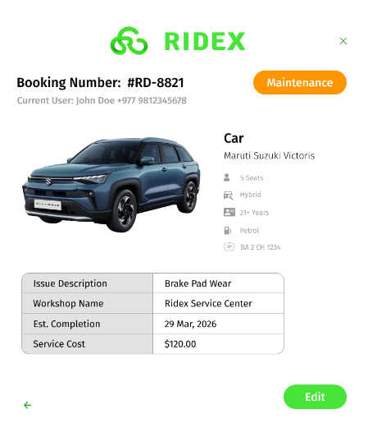
Fig 14.4.1: Maintenance Pop Up Read Vehicle
Description: This is a shared modal. This shows up after clicking the update button after filling up the maintenance form. The change showed is the removal of the maintenance icon and the car status changing to orange and from available to maintenance. You can also edit the maintenance form which will be talked about later.

Admin Manage Fleet Unavailable
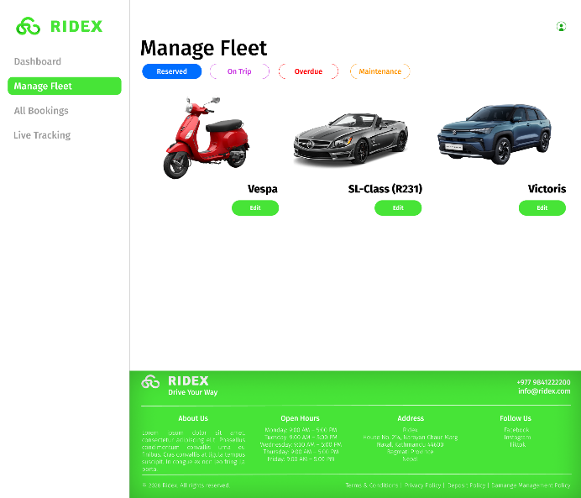
Fig 15.1: Manage Fleet Unavailable Vehicles Reserved
Description: When clicked on the unavailable button from the main manage fleet section it takes to this page to manage unavailable fleet which is also categorized into 4 sections matching the car status. Clicking on the manage fleet on the side bar should take you back to the main manage fleet page. You can click to edit the vehicle which will be discussed later. There is no delete vehicle button in any unavailable manage fleet category.
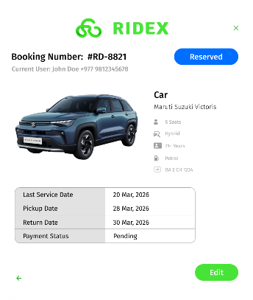
Fig 15.1.1: Read Reserved Vehicle
Description: When clicked in manage fleet reserved listing’s image the read reserved vehicle modal pops up which includes a booking number alongside its user who booked the car with their name and number and on the right the specific car status. The table for reserved vehicle is different than that of available vehicle. It includes last service date, pickup date, return date, payment status. With an edit button but no delete button.

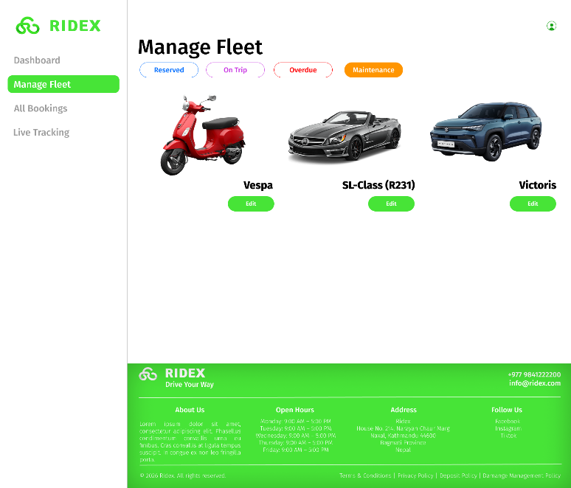
Fig 15.2: Manage Fleet Unavailable Vehicles Maintenance
Description: When clicked on the maintenance button in manage fleet’s unavailable section it takes to this page. The edit button here is separate from all other manage fleets edit vehicle since this one is specifically about edit the maintenance status.
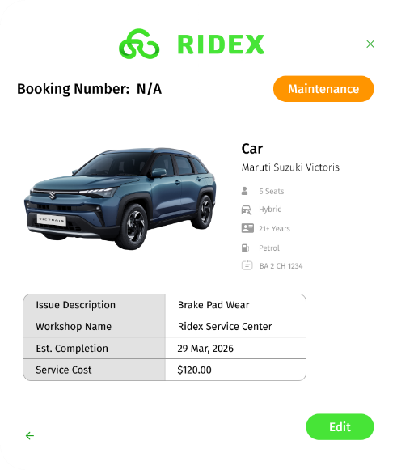
Fig 15.2.1: Read Maintenance Vehicle
Description: When clicked in manage fleet maintenance listing’s image the read maintenance vehicle modal pops up which includes a booking number as N/A since its not booked or reserved by anyone and on the right the specific car status. The table for maintenance vehicle is different than that of another vehicles. It includes issue description, workshop name, est. completion, service cost. With an edit button but no delete button.
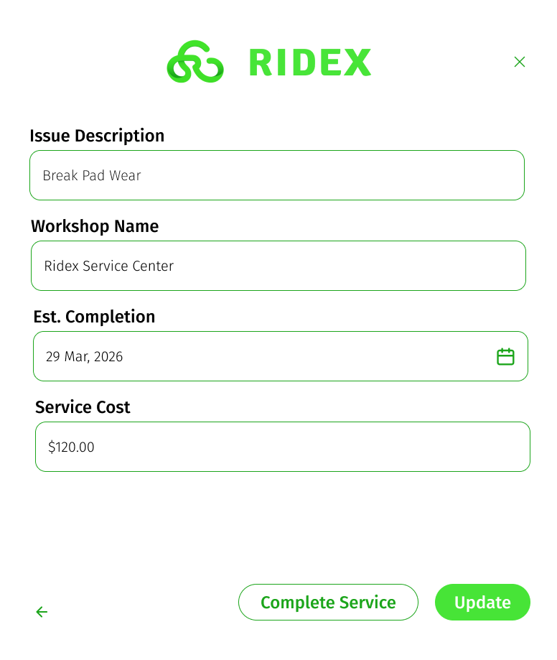
Fig 15.2.2: Maintenance form Edit
Description: The text field is all the same from the initial maintenance form but you can update the text fields and there is complete service button to mark the vehicle as maintenance completed and it automatically shifts the car status to available.

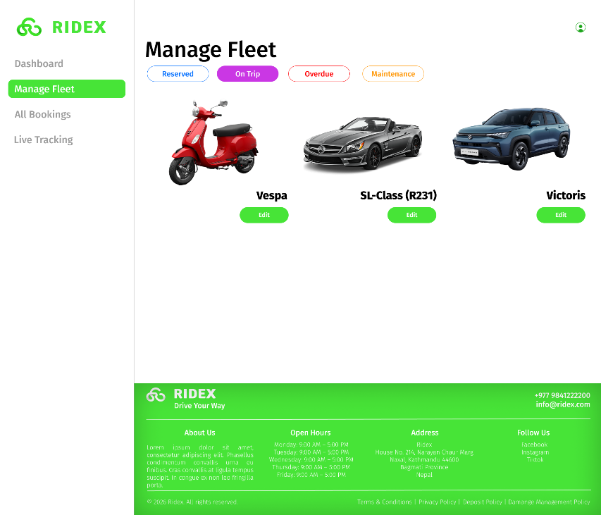
Fig 15.3: Manage Fleet Unavailable Vehicles On Trip
Description: When clicked on the On Trip button in manage fleet’s unavailable section it takes to this page. It shows all the vehicle categories that are currently active and on trip.
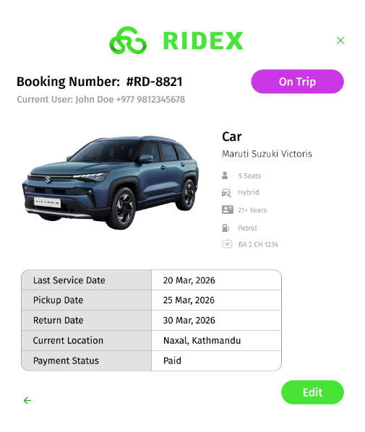
Fig 15.3.1: Read On Trip Vehicle
Description: Shows booking number, user detail, car status, edit button and its specific table that contains last service date, pickup date, return date, current location, payment status. (BTW all vehicles need to be paid for either at booking or while pickup so there are no hiccups for payment or payment issues later so automatically all on trip vehicles are paid for and reserved could be either paid or pay on arrival.)
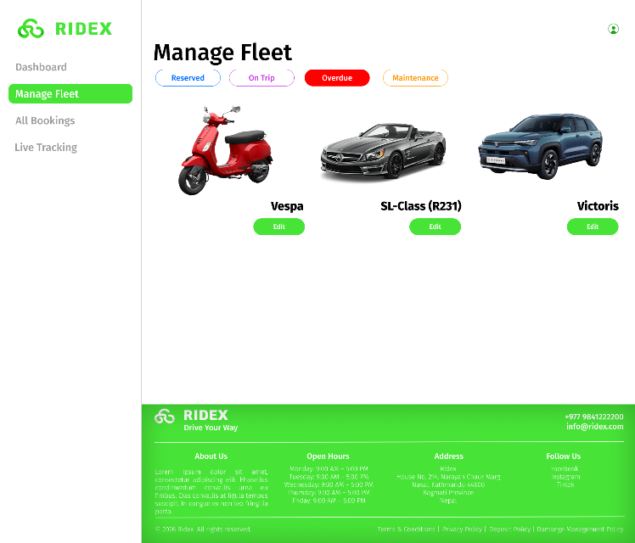
Fig 15.4: Manage Fleet Unavailable Vehicles Over Due
Description: When clicked on the Over Due button in manage fleet’s unavailable section it takes to this page. It shows all the vehicle categories that are currently active and over due that goes past the return date.
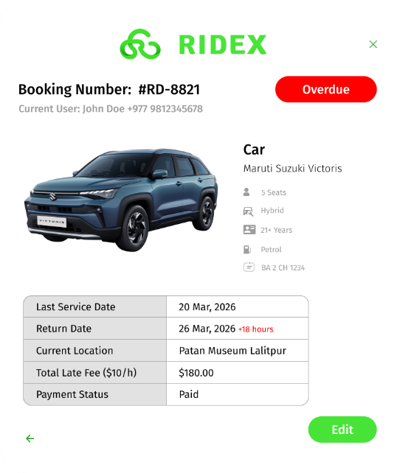
Fig 15.3.1: Read Overdue Vehicle
Description: Shows booking number, user detail, car status, edit button and its specific table that contains last service date, return date, current location, total late fee, payment status. The table for all 5 categories should be generated automatically with available data and not have to be typed in manually.

Example Read Vehicle Categories other from cars
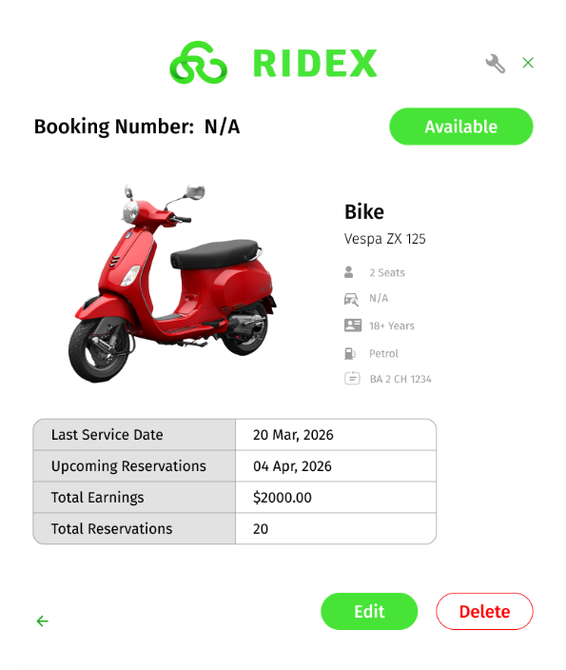
Fig: Read Vehicle Bike
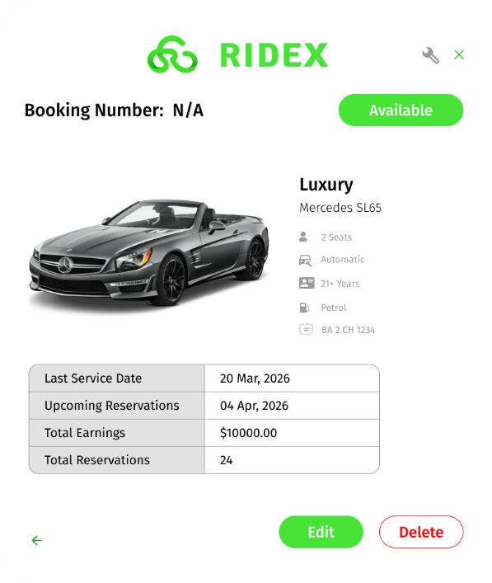
Fig: Read Vehicle Luxury

Create Vehicle Form Universal
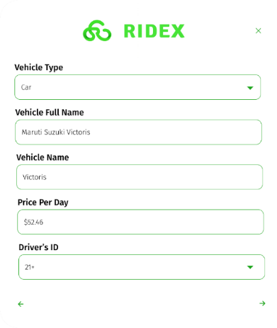
Fig 16.1: Create Vehicle Part 1
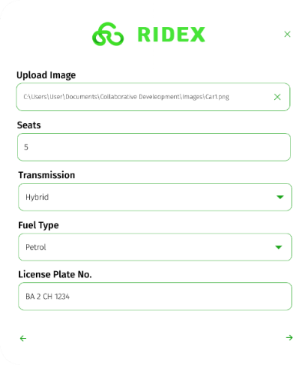
Fig 16.2: Create Vehicle Part 2
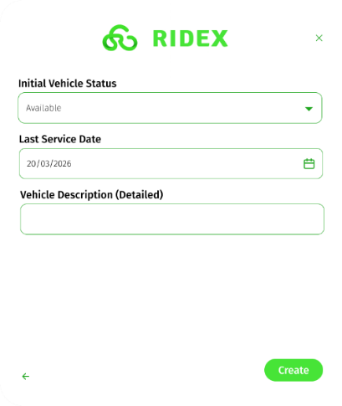
Fig 16.3: Create Vehicle Part 3

Vehicle Creation Form Specification Admin
1. Vehicle Type
- Dropdown menu with the following options:
  - Car
  - Bike
  - Luxury
- Used to categorize vehicles for filtering and display.

2. Vehicle Name
- Short name of the vehicle
- Displayed in listings, cards, and previews.

3. Vehicle Full Name
- Complete name of the vehicle (e.g., brand + model)
- Displayed on the detailed vehicle page.

4. Price Per Day
- Numeric input
- Represents the rental cost per day.

5. Driver Requirement
- Dropdown menu:
  - Age 18
  - Age 21
- Indicates the minimum age requirement for renting the vehicle.

6. Vehicle Image Upload
- Allows uploading an image of the vehicle
- Used for display in listings and detailed view.

7. Transmission Type
- Dropdown menu:
  - Manual
  - Automatic
  - Hybrid

8. Fuel Type
- Dropdown menu:
  - Petrol
  - Diesel

9. License Plate Number
- Text input
- Unique identifier for each vehicle.

10. Initial Vehicle Status
- Dropdown menu with five predefined statuses
- Used to indicate availability or condition of the vehicle (as defined in system requirements).

11. Last Service Date
- Date input
- Records the most recent servicing of the vehicle.

12. Vehicle Detailed Description
- Text area input
- Provides detailed information about the vehicle
- Displayed on the vehicle detail page for users.

Edit Vehicle Form
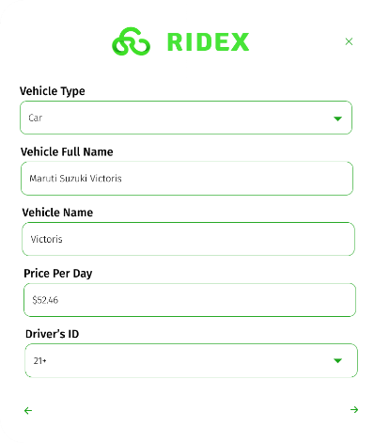
Fig 17.1: Edit Vehicle Part 1
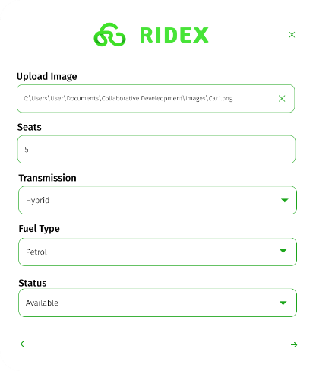
Fig 17.2: Edit Vehicle Part 2

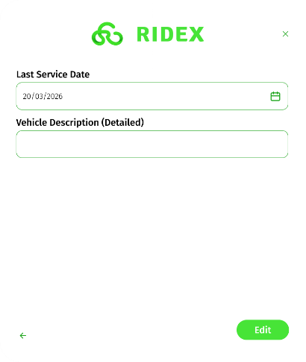
Fig 17.3: Edit Vehicle Part 3

Vehicle Edit Form Specification
The vehicle edit module allows administrators to update existing vehicle details. All fields are pre-filled with current data and can be modified as required.

Fields and Requirements

1. Vehicle Type
- Dropdown menu:
  - Car
  - Bike
  - Luxury
- Allows updating the category of the vehicle.

2. Vehicle Name
- Short name used in listings and previews
- Can be edited for display purposes.

3. Vehicle Full Name
- Complete name of the vehicle (brand + model)
- Displayed on the detailed vehicle page.

4. Price Per Day
- Numeric input
- Updated to reflect current rental pricing.

5. Driver Requirement
- Dropdown menu:
  - Age 18
  - Age 21
- Defines the minimum age requirement for renting.

6. Vehicle Image Upload
- Option to upload a new image
- Replaces the existing vehicle image if updated.

7. Number of Seats
- Numeric input
- Specifies seating capacity of the vehicle.

8. Transmission Type
- Dropdown menu:
  - Manual
  - Automatic
  - Hybrid

9. Fuel Type
- Dropdown menu:
  - Petrol
  - Diesel

10. Vehicle Status
- Dropdown menu with predefined status options
- Used to update availability or condition of the vehicle.

11. Last Service Date
- Date input
- Updated to reflect the most recent servicing.

12. Vehicle Detailed Description
- Text area input
- Editable description shown on the vehicle detail page.

Admin All Bookings
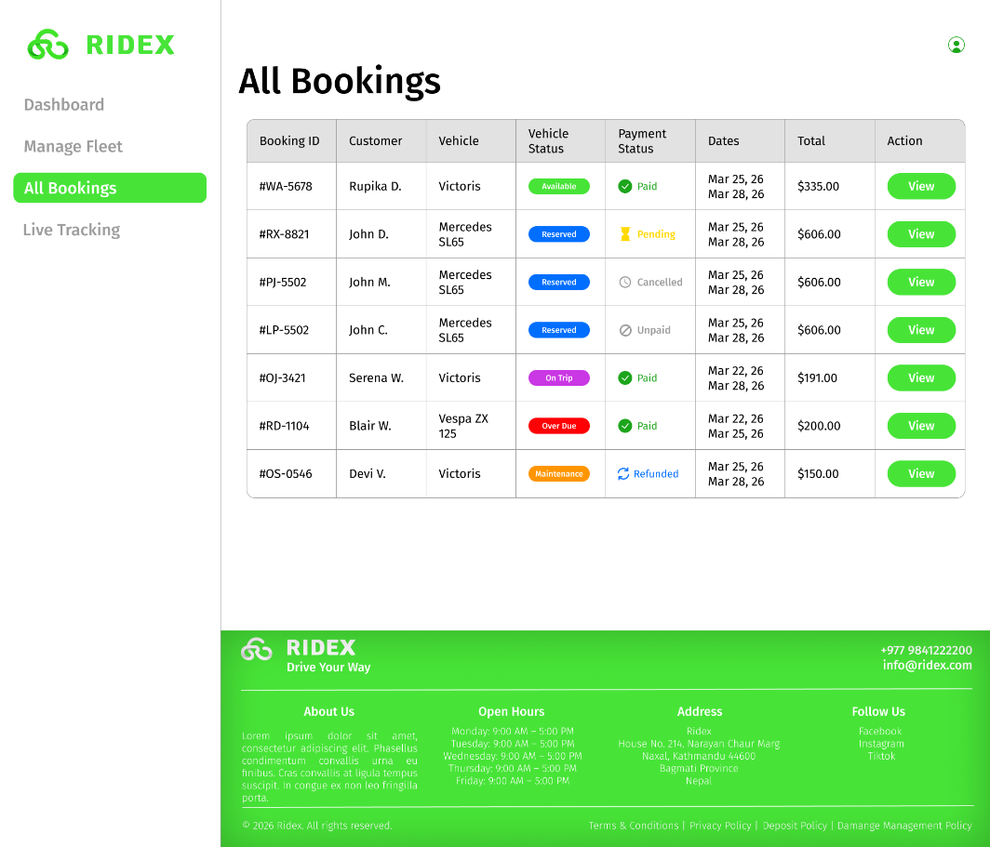
Fig 18.1: Admin All Booking Page
The “All Bookings” section allows administrators to view and manage all bookings in the system, including past, current, and future reservations.

Search Functionality (AJAX Live Search)
- This page includes a live search feature (not present in other sections).
- Implemented using AJAX, allowing real-time filtering.
- As the admin types (e.g., “K”), matching results are instantly displayed without refreshing the page.

Layout Design
- A table layout is used instead of card-based UI.
- This ensures structured and efficient viewing of large amounts of booking data.

Table Columns
1. Booking ID
- Unique identifier for each booking.

2. Customer
- Displays the customer’s name in shortened format
- Example: John D. instead of John Doe

3. Vehicle
- Displays the vehicle full name (recommended for clarity)

4. Vehicle Status
- Displays “Car Status” (current status) of the vehicle:
  - Available
  - Reserved
  - On Trip
  - Ready
  - Maintenance
- Shown as a non-clickable button-style label
- Color-coded for quick visual identification

5. Payment Status
- Displays the payment condition of the booking
- Also color-coded
Status Types:
- Paid
  - Full payment completed at booking
- Pending
  - Booking confirmed but payment will be made on arrival
- Cancelled
  - Booking cancelled but refund not yet processed
- Refunded
  - Payment returned after admin-approved cancellation
- Unpaid
  - Booking cancelled before payment was made (no transaction occurred)

6. Dates
- Displays:
  - Pick-up date
  - Return date
- Format:
Mar 25, 2026
Mar 28, 2026

7. Total
- Displays the total booking cost

8. Action
- Contains a View button

View Booking Details
- The View button redirects to a detailed booking modal
- This page includes:
  - Full booking information
  - Customer details
  - Vehicle details
  - Payment breakdown
  - Booking status
(Detailed design of this page is defined separately.)

Detailed Booking Information
After clicking the View button in the Actions columns, the specific booking’s detailed confirmation modal opens.
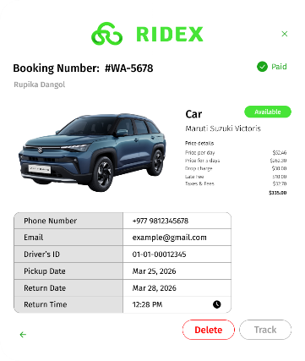
Fig 19.1: Detailed Booking Information Modal (Paid/Available)
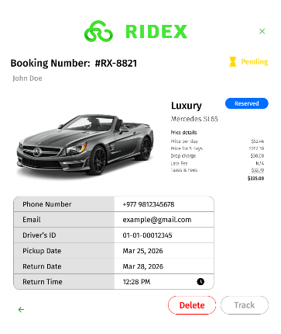
Fig 19.2: Detailed Booking Information Modal (Pending/Reserved)
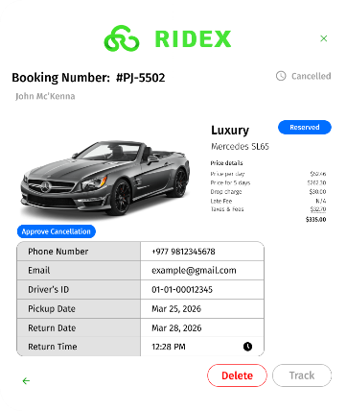
Fig 19.3: Detailed Booking Information Modal (Cancelled/Reserved)
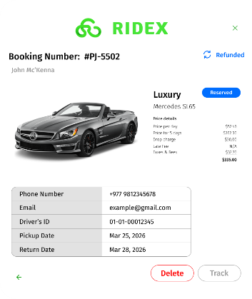
Fig 19.3.1: Detailed Booking Information Modal after approving cancellation of prepaid payment (Refunded/Reserved)
(After approving the cancellation if the payment status was “cancelled” the status for payment status goes to “refunded” else if it is “unpaid” there is nothing to return so the status remains unpaid. And after clicking the approve cancellation the cancellation gets approved and the button of “approve cancellation” gets removed)
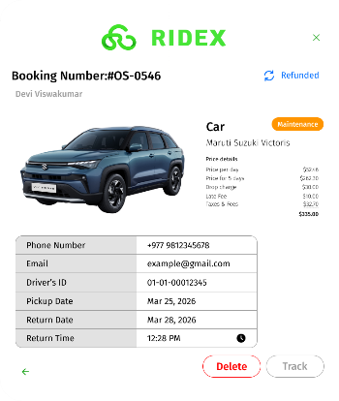
Fig 19.4: Detailed Booking Information Modal (Refunded/Maintenance)
The booking detail modal is displayed when the admin clicks the “View” button in the “All Bookings” table. It provides complete booking information and allows status updates and actions.

  - 1. Modal Structure
- Opens as a popup dialog
- Layout remains consistent across bookings
- Content dynamically changes based on booking data

  - 2. Header Section
- Booking Number displayed at the top with user’s name
- Payment Status shown on the right with icon
- Status is color-coded for quick identification

  - 3. Customer Information
- Customer name displayed

  - 4. Vehicle Information
- Vehicle image displayed
- Beside the image:
  - Vehicle type (Car / Bike / Luxury)
  - Vehicle full name
- Vehicle status displayed as a non-clickable button-style label: (It is the recent most status of the vehicle itself not dependent on the booking or payment data of the specific user.)
  - Available
  - Reserved
  - On Trip
  - Maintenance
  - Overdue

  - 5. Billing Section
- Displays pricing breakdown:
  - Price per day
  - Number of days
  - Extra charges
  - Late fee (if applicable)
  - Total amount

  - 6. Booking Details Table
A structured table displaying:
- Phone Number
- Email
- Driver’s ID
- Pickup Date
- Return Date
- Return Time (admin input)
  - Behavior
- Data is automatically populated from booking records
- Admin manually enters Return Time

  - 7. Late Fee Calculation
- If return time matches expected return → Late fee = N/A
- If returned late → Late fee calculated automatically
- Applies to:
  - On Trip
  - Overdue bookings

  - 8. Action Buttons
Delete Button
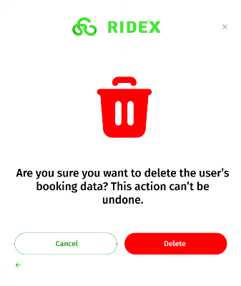
Fig 19.5: Delete Booking Data Confirmation Modal
- Opens a confirmation modal
- Prevents accidental deletion
- Booking is deleted only after confirmation

Track Button
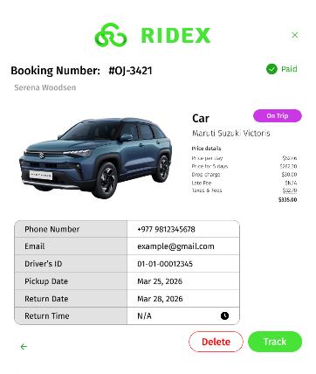
Fig 19.6: Detailed Booking Information Modal (Paid/On Trip)
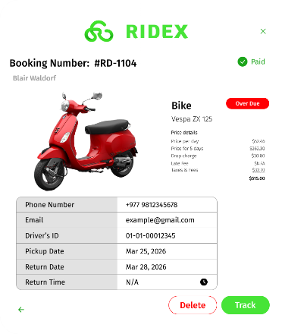
Fig 19.7: Detailed Booking Information Modal (Paid/Over Due)
- Enabled only when:
  - Vehicle status = On Trip
  - Vehicle status = Overdue
- Disabled when:
  - Vehicle status = Available
  - Vehicle status = Reserved
  - Vehicle status = Maintenance

  - 9. Tracking Modal [planned for future implementation (Sprint 2)]
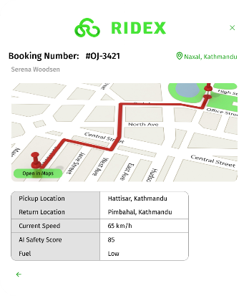
Fig 19.8: Detailed GPS Tracking
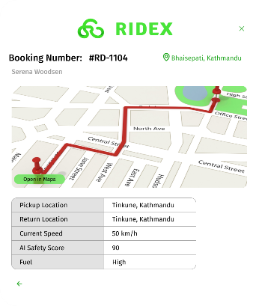
Fig 19.9: Detailed GPS Tracking 2
Triggered when clicking Track
  - Displays:
- Booking number
- Customer name
- Live location map
  - Tracking Table Includes:
- Pickup Location
- Return Location
- Current Speed
- AI Safety Score
- Fuel Level

  - Additional Feature
- Open in Maps button → opens location in browser
Note
- AI-based values (Location, speed, safety score, fuel)

  - 10. Cancellation Handling
- If a user requests cancellation:
  - Booking does not immediately cancel
  - Admin Control
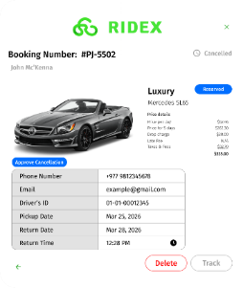
- “Approve Cancellation” button appears in modal
Behavior
- On approval:
  - Status → Cancelled
  - If prepaid → Refund processed
  - Button is removed after approval

  - 11. Status Transition Logic
- On Trip / Overdue → Available
  - When vehicle is returned
  - Admin enters return time
  - Late fee calculated
  - Status automatically updates to Available

  - 12. System Behavior Summary
- Modal dynamically updates based on booking state
- Actions are condition-based (track, delete, approve)
- Data consistency maintained through:
  - Auto-filled fields
  - Admin-controlled inputs
  - Status-driven logic

Admin Live Tracking
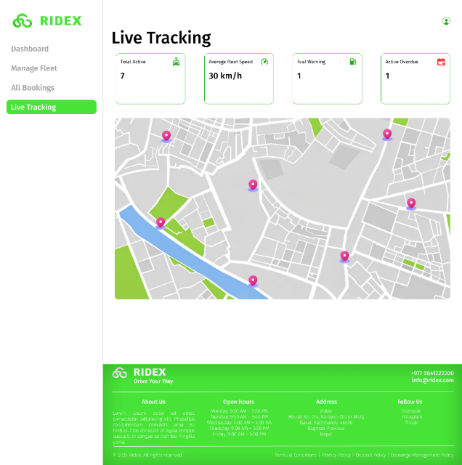
Fig 20.1: Live Tracking Page
The live tracking page for admins features four key cards, each displayed in a rectangular UI:
- Total Active – Shows the number of vehicles currently rented out.
- Average Fleet Speed – Displays the average speed of all active vehicles.
- Fuel Warning – Highlights vehicles with low fuel, whether petrol, diesel, or electric.
- Active Overdue – Indicates active vehicles that are past their due date.
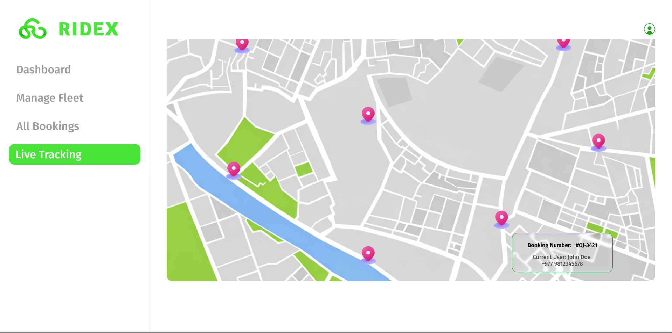
Fig 20.2: Map Hover State
Below the cards, there is a map view showing location icons for each active vehicle. For example, if there are seven active vehicles, seven icons will appear automatically. Each icon represents a different vehicle, and clicking on it will center the map on that vehicle’s location while hovering on it will show short details like the “Booking Number” & “Current User: Full Name + Number”.

Images & Logos

Fig 21.1: 4 images of the app logo text and icon in white and green


Fig 21.2: Banner Image of Home/Landing Page

